Contents

1. Evaluation Report 3

1.1. History on Distributed Computing 3

1.2. Architecture of Distributed Computing 3

1.3. Microservices 4

1.4. Microservices in the Distributed Web Application 5

1.5. Spring Boot Microservices Framework 5

1.6. Play Microservices Framework 7

1.7. Justifications for Spring Framework 9

2. Presentation Tier 11

2.1. Introduction 11

2.1.1. JSP 11

2.1.2. Servlets 12

2.1.3. Diagram 13

2.2. Admin 13

2.2.1. Login 13

2.2.2. Register new user 15

2.2.3. Update, search, delete users 17

2.2.4. Assign lecturer to department 19

2.2.5. Student’s attendance and classes 20

2.2.6. Additional features 21

2.3. Head of School 24

2.3.1. Login 24

2.3.2. Edit profile 25

2.3.3. Create/update/delete class and assign lecturer 25

2.3.4. View attendance 27

2.4. Lecturer 28

2.4.1. Login 28

2.4.2. Edit profile 29

2.4.3. Take attendance 29

2.4.4. Modify/view attendance 31

2.5. Student 33

2.5.1. Login 33

2.5.2. Edit profile 33

2.5.3. View attendance summary 34

3. Business Tier 35

3.1. Introduction 35

3.1.1. Entity Beans 35

3.1.2. Session Beans 36

3.1.3. Diagram 37

3.2. EJB 37

3.2.1. Lecturers 37

3.2.2. Students 38

3.2.3. AssignLtd 38

3.2.4. AssignStc 39

3.2.5. Department 39

3.2.6. Classes 40

3.2.7. Attendance 40

4. Database Tier 42

4.1. Diagram 42

4.2. Tables 42

4.2.1. Lecturers and Students 42

4.2.2. Assign_LTD 42

4.2.3. Assign_STC 42

4.2.4. Class 42

4.2.5. Department 42

4.2.6. Attendance 42

5. Summary of Entire Architecture 43

6. Additional Features 44

6.1. JavaScript 44

6.2. CSS 44

6.3. Bootstrap Framework 45

7. References 47

8. Marking Scheme 48

# 1. Evaluation Report

## 1.1. History on Distributed Computing

Distributed computing is a field of computer science that studies distributed systems. A distributed system is a system whose components are located on different networked computers, which then communicate and coordinate their actions by passing messages to each other. The components interact with each other in order to achieve a common goal. Three significant characteristics of distributed systems are: concurrency of components, lack of a global clock, and independent failure of components [Coulouris, 2011].

A distributed system may have a common goal, such as solving a large computational problem. The user then perceives the collection of autonomous processors as a unit. Alternatively, each computer may have its own user with individual needs, and the purpose of the distributed system is to coordinate the use of shared resources or provide communication services to the users [Ghosh, 2007].

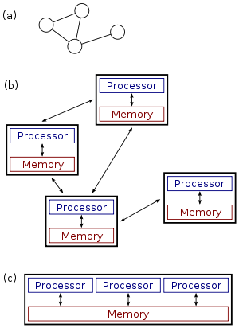The use of concurrent processes that communicate by message-passing has its roots in operating system architectures studied in the 1960s.The first widespread distributed systems were local-area networks such as Ethernet, which was invented in the 1970s. ARPANET, the predecessor of the Internet, was introduced in the late 1960s, and ARPANET e-mail was invented in the early 1970s. E-mail became the most successful application of ARPANET, and it is probably the earliest example of a large-scale distributed application. In addition to ARPANET, and its successor, the Internet, other early worldwide computer networks included Usenet and FidoNet from the 1980s, both of which were used to support distributed discussion systems.

*Figure 1.1: (a), (b): a distributed system.*

*(c): a parallel system.*

The study of distributed computing became its own branch of computer science in the late 1970s and early 1980s. The first conference in the field, Symposium on Principles of Distributed Computing, dates back to 1982, and its counterpart International Symposium on Distributed Computing was first held in Ottawa in 1985 as the International Workshop on Distributed Algorithms on Graphs [Tel, 2000].

## 1.2. Architecture of Distributed Computing

Various hardware and software architectures are used for distributed computing. At a lower level, it is necessary to interconnect multiple CPUs with some sort of network, regardless of whether that network is printed onto a circuit board or made up of loosely coupled devices and cables. At a higher level, it is necessary to interconnect processes running on those CPUs with some sort of communication system [Ohlídal, 2006].

Distributed programming typically falls into one of several basic architectures: client–server, three-tier, n-tier, or peer-to-peer; or categories: loose coupling, or tight coupling [Ms.Kamble, 2005].

* Client–server: architectures where smart clients contact the server for data then format and display it to the users. Input at the client is committed back to the server when it represents a permanent change.
* Three-tier: architectures that move the client intelligence to a middle tier so that stateless clients can be used. This simplifies application deployment. Most web applications are three-tier.
* n-tier: architectures that refer typically to web applications which further forward their requests to other enterprise services. This type of application is the one most responsible for the success of application servers.
* Peer-to-peer: architectures where there are no special machines that provide a service or manage the network resources. Instead all responsibilities are uniformly divided among all machines, known as peers. Peers can serve both as clients and as servers.

Another basic aspect of distributed computing architecture is the method of communicating and coordinating work among concurrent processes. Through various message passing protocols, processes may communicate directly with one another, typically in a master/slave relationship. Alternatively, a "database-centric" architecture can enable distributed computing to be done without any form of direct inter-process communication, by utilizing a shared database [Lind, 2006].

## 1.3. Microservices

Computer microservices can be implemented in different programming languages and might use different infrastructures. Therefore, the most important technology choices are the way microservices communicate with each other and the protocols used for the communication. In a traditional system most technology choices like the programming language impact the whole systems. Therefore, the approach for choosing technologies is quite different [Cormen, 1990]. Microservices architectures have given rise to many approaches for making them work well at varying degrees of scale. One widely discussed pattern for large-scale microservices development and delivery is the service mesh pattern [Cole, 1986].

In a service mesh, each service instance is paired with an instance of a reverse proxy server, called a service proxy, sidecar proxy, or sidecar. The service instance and sidecar proxy share a container, and the containers are managed by a container orchestration tool such as Kubernetes [Cole, 1986]. The service proxies are responsible for communication with other service instances and can support capabilities such as service discovery, load balancing, authentication and authorization, secure communications, and others.

In a service mesh, the service instances and their sidecar proxy are said to make up the data plane, which includes not only data management but also request processing and response. The service mesh also includes a control plane for managing the interaction between services, mediated by their sidecar proxies. The most widely discussed service mesh architecture today is Istio, a joint project among Google, IBM, and Lyft.

## 1.4. Microservices in the Distributed Web Application

The times of Java EE application server and monolithic software architectures are nearly gone. Hardware is not getting faster anymore, but internet traffic is still increasing. Platforms have to support scaling out. Load must be distributed to several hosts. Microservice-based architectures can offer solutions for this requirement. Apart from the better scaling, microservices offer faster development cycles, dynamic scaling depending on load and improved failover behavior.

Instead of duplicating a full system in order to handle a higher demand, in microservices architectures, only the parts which need more resources need to be scaled. Software can be decoupled, and maintenance of software is getting easier. Every developer who had to update a hibernate version in a monolithic application knows the pain of keeping a monolith up to date and reducing technical debt. With microservices, you can do this step by step, service by service. With an increasing number of services, every overhead needs to be minimized. Heavy application servers are not the tool to use for this. Web applications or services can be implemented by using embedded web servers for a while. Instead of installing full JEE profile application server and instead of deploying EAR or WAR files, a simple self-running jar can do the job. This is not new, but in order to create such services fast, a template or framework is needed. Such frameworks are prominent in other languages but for Java, there were only a few options available. That changed. With Dropwizard, the Play Framework or Spring Boot there are at least 3 frameworks which are heavily in use in the Java microservice world.

## 1.5. Spring Boot Microservices Framework

Microservices allow large systems to be built up from a number of collaborating components. It does at the process level what Spring has always done at the component level: loosely coupled processes instead of loosely coupled components. Spring is a very popular Java-based framework for building web and enterprise applications. Unlike many other frameworks, which focus on only one area, Spring framework provides a wide verity of features addressing the modern business needs via its portfolio projects.

Spring framework provides flexibility to configure beans in multiple ways such as XML, Annotations, and JavaConfig. With the number of features increased the complexity also gets increased and configuring Spring applications becomes tedious and error-prone.

Spring is very popular because of several reasons:

* Spring’s dependency injection approach encourages writing testable code
* Easy to use but powerful database transaction management capabilities
* Spring simplifies integration with other Java frameworks like JPA/Hibernate ORM, Struts/JSF/etc. web frameworks
* State of the art Web MVC framework for building web applications

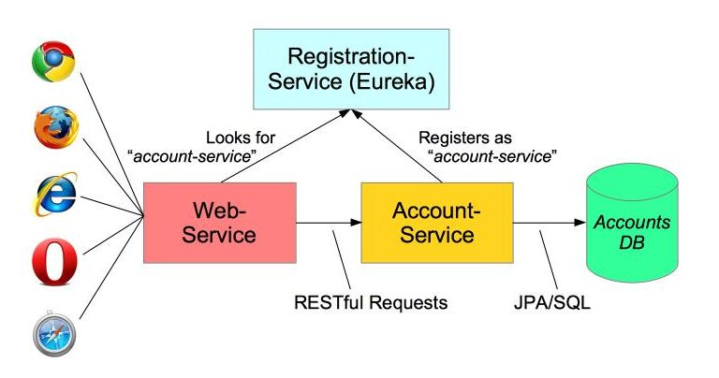

Figure 1.2: Spring Boot diagram

In pursuit of such an improved development experience, Spring Boot — and, indeed, the entire Spring ecosystem — has embraced the Groovy programming language. Groovy’s powerful MetaObject protocol, pluggable AST transformation process, and embedded dependency resolution engine are what facilitate many of the shortcuts that Boot affords. At the core of its compilation model, Boot utilizes Groovy to build project files, so that it can decorate a class' generated bytecode with common imports and boilerplate methods, such as a class' main method. This allows applications written with Boot to remain concise, while still offering a breadth of functionality.

**Pros:**

* Simplified & version conflict free dependency management through the starter POMs.
* We can quickly setup and run standalone, web applications and micro services at very less time.
* You can just assemble the jar artifact which comes with an embedded Tomact, Jetty or Undertow application server and you are ready to go.
* Spring Boot provides HTTP endpoints to access application internals like detailed metrics, application inner working, health status, etc.
* No XML based configurations at all. Very much simplified properties. The beans are initialized, configured and wired automatically.
* The Spring Initializer provides a project generator to make you productive with the certain technology stack from the beginning. You can create a skeleton project with web, data access (relational and NoSQL datastores), cloud, or messaging support.

**Cons:**

* Spring boot may unnecessarily increase the deployment binary size with unused dependencies.
* If you are a control freak, I doubt Spring Boot would fit your needs.
* Spring Boot sticks good with micro services. The Spring Boot artifacts can be deployed directly into Docker containers. In a large and monolithic based application, I would not encourage you to use Spring Boot.

## 1.6. Play Microservices Framework

Play is a stateless, asynchronous, and non-blocking framework that uses an underlying fork-join thread pool to do work stealing for network operations and can leverage Akka for user level operations.

One person ripping pages out and feeding pages into a shredder is doing as much work as possible, but the IO -- the cost of going backwards and forwards between different rooms -- means that the shredder is idle while the person is bringing more pages to it. Even worse, sometimes the door to the book room is locked, and the person has to wait until the door opens again.

You can shred more pages if you add more people. Each person will hold some pages out of a book, and they will hold those pages and make an orderly line to the shredder. If you calculate it right, the average wait time balances out with the arrival and departure time and the shredder always has pages to shred.

So far so good. But there's a wrinkle: there's never one single HTTP request. Instead, there are multiple HTTP requests. So, in our imaginary model, there are multiple books, each in their own room, and a number of people that take pages out of those books and line up behind the shredder.

There's another wrinkle: all the HTTP requests have to be served at roughly the same rate. This means that there has to be some fairness, so that people don't all go to the same room and rip all the pages out of one book, while neglecting all the others.

The Java servlet model was invented in 1998 and ensured fairness through a "thread per request" model–every book had a person assigned to it, and everyone lined up in front of a single shredder. This was a huge advance at the time, as the alternatives were horribly inefficient.

Java EE application servers are all built on top of servlets, and so inherit from the underlying assumptions of the threading model. In particular, Java EE applications typically make heavy use of ThreadLocal as a way to ensure an implicit context for the request–this is like putting a sticky note on the person handling the book, and it means that even when the person you're looking at isn't in the book room, you can still identify them.

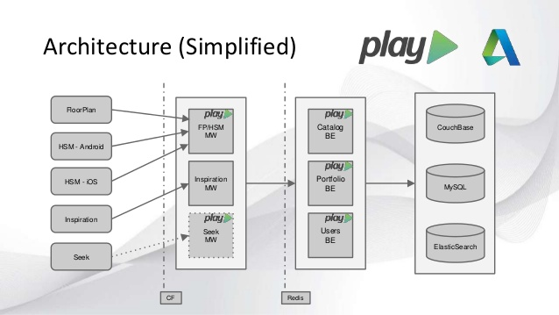

Figure 1.3: Play framework architecture

This worked at the time, when there was a single CPU with a single core. But computers added multiple CPUs and cores, and CPU cores got faster than network and disk access did. Now, not only are there more shredders, but they also chew through paper faster. The people that feed the paper to the shredders must move as fast as possible in order to meet demand. This is where the "thread per request" model has a problem. If there is any blocking in the request–if the door is locked–then the person is out of action and cannot feed paper.

Java 1.6 and 1.7 made great strides in thread management and non-blocking IO. Play takes full advantage of these new APIs, building directly on a thread pool that enables work stealing. Because Play is non-blocking, threads are not blocked when the network is slow, but are free to serve another HTTP request–and because Play is stateless, there is no session information tied to the thread that would confuse it.

In shredder terms, if a person is taking pages from a book, and goes back to find the door locked, that person can try another door and take pages from a different book -- all while maintaining levels of fairness between the books being shredded and the lines for the various shredders.

**Pros:**

* Easy to learn, in comparison to Spring MVC.
* Play JSON, and Play WS are quite good, and easy to work with.
* The fact that many components are separate dependencies. For example, I’ve used play-json, and play-ws, in other projects, outside of play-framework. This also allows one to exclude parts from a Play Framework project, that they don’t use.
* Good test libraries, specific support from Scalatest, and Specs2. Easy to test end-to-end, starting from routing the request, all the way back. There’s even support for FluentLenium (but I haven’t tried it).

**Cons:**

* Overall, the framework can be quite volatile at times.
* The relatively recent move to dependency injection by default. Functional languages (I.E. Scala), do not need DI, per se.

## 1.7. Justifications for Spring Framework

**Developer productivity**

Spring takes a long time start and to see a change, you have to restart it (which can take minutes for a large app); the APIs are clunky; it has few built-in bells and whistles that you need to build a modern app. In fact, talk to developers at just about any company that has a reasonably large Spring MVC deployment and you'll find a dirty secret: they all build custom frameworks on top of it (most of which are poorly tested, documented, supported, etc). LinkedIn was no exception. Hell, even the folks at Springsource itself had to build another layer on top Spring MVC called Spring Boot. Why? Because Spring MVC, itself, is damn-near unusable. On the other hand, Play can hot-reload changes, so you get in a wonderful code-refresh-code-refresh cycle (see changes in seconds); the APIs are powerful & composable (see functional programming below); and it's a modern framework with built-in support for most common tasks (JSON, web sockets, DB access, web service calls, etc).

**Non-blocking I/O**

Spring is blocking, which means any time you do I/O (make a remote service call, process a client request, etc), it holds up a thread. This makes it tough to scale, which is problematic, as most modern apps spend most of their time doing I/O. Play is fully non-blocking, which means it performs better in a service-oriented architecture (what the cool kids are calling "microservices" these days) and it can support web sockets, streaming, etc (see Play Framework: async I/O without the thread pool and callback hell). This opens up some amazing possibilities, such as BigPipe style streaming (see Composable and Streamable Play Apps and Ping-Play: Big Pipe Streaming for the Play Framework).

**Functional programming**

Spring is built around a bunch of mutable objects, annotations, XML configuration files, and other magic. This seems OK at first, until something goes wrong; or you need to do something slightly custom; or you have a large app and can't follow all the places that side effects are happening. In short, most Spring MVC apps are a giant ball of Spaghetti. On the other hand, Play is built around a functional programming core. Just about everything is a function that returns a value, and they make excellent use of the type system (not only type-safe classes, but also type-safe routes, templates, build system, and more) which makes it much easier to reason about the code, compose and reuse pieces of your app, debug problems, plug in custom behavior, and so on.

**Better error reporting**

With Spring, you get a gigantic, incomprehensible stack trace in an obscure log file. With Play, you get a clear error message and a snippet of the broken code right in the browser. It's also worth mentioning that Play makes much better use of the type system, so most errors you get are compile-time errors instead of run-time errors.

In conclusion, Spring has async in its WebMVC offering, and a new project named Reactor that is an incredibly fast threadpool or eventloop for async processing.  Spring also now has java configuration instead of XML and you can scan your classpath to pick up components, so you don't even have to explicitly wire things up if you don't want to.  It also is just a better ecosystem because it provides a sane, pattern-oriented way of doing anything else you want to do (upload files, talk to RMQ, talk to Redis, schedule tasks, etc.), so you know you'll be safe in the future picking spring as well.

# 2. Presentation Tier

## 2.1. Introduction

### 2.1.1. JSP

Java Server Pages (JSP) is a server-side programming technology that enables the creation of dynamic, platform-independent method for building Web-based applications. JSP have access to the entire family of Java APIs, including the JDBC API to access enterprise databases. This tutorial will teach you how to use Java Server Pages to develop your web applications in simple and easy steps.

Architecturally, JSP may be viewed as a high-level abstraction of Java servlets. JSPs are translated into servlets at runtime, therefore JSP is a Servlet; each JSP servlet is cached and re-used until the original JSP is modified. JSP can be used independently or as the view component of a server-side model–view–controller design, normally with JavaBeans as the model and Java servlets (or a framework such as Apache Struts) as the controller. This is a type of Model 2 architecture [Sun Microsystems].

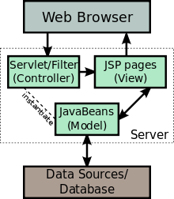JSP allows Java code and certain pre-defined actions to be interleaved with static web markup content, such as HTML, with the resulting page being compiled and executed on the server to deliver a document. The compiled pages, as well as any dependent Java libraries, contain Java bytecode rather than machine code. Like any other Java program, they must be executed within a Java virtual machine (JVM) that interacts with the server's host operating system to provide an abstract, platform-neutral environment. JSPs are usually used to deliver HTML and XML documents, but through the use of OutputStream, they can deliver other types of data as well.

Figure 1.4: JSP Model

Java code is not required to be complete or self-contained within a single scriptlet block. It can straddle markup content, provided that the page as a whole is syntactically correct. For example, any Java if/for/while blocks opened in one scriptlet must be correctly closed in a later scriptlet for the page to successfully compile. Content that falls inside a split block of Java is subject to that code. Content inside an if block will only appear in the output when the if condition evaluates to true. Likewise, content inside a loop construct may appear multiple times in the output, depending upon how many times the loop body runs. The following would be a valid for loop in a JSP page:

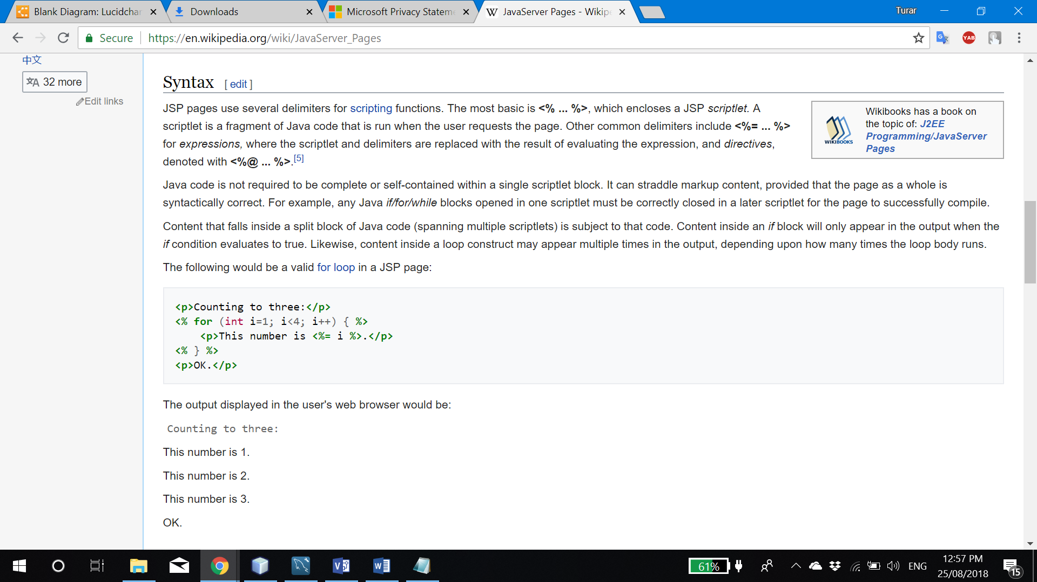

Figure 1.5: JSP example

### 2.1.2. Servlets

Servlets provide a component-based, platform-independent method for building Webbased applications, without the performance limitations of CGI programs. Servlets have access to the entire family of Java APIs, including the JDBC API to access enterprise databases. This tutorial will teach you how to use Java Servlets to develop your web based applications in simple and easy steps.

A servlet is a Java programming language class used to extend the capabilities of servers that host applications accessed by means of a request-response programming model. Although servlets can respond to any type of request, they are commonly used to extend the applications hosted by web servers. For such applications, Java Servlet technology defines HTTP-specific servlet classes.

The javax.servlet and javax.servlet.http packages provide interfaces and classes for writing servlets. All servlets must implement the Servlet interface, which defines lifecycle methods. When implementing a generic service, you can use or extend the GenericServlet class provided with the Java Servlet API. The HttpServlet class provides methods, such as doGet and doPost, for handling HTTP-specific services.

The following example in Figure 1.6. servlet prints how many times its service() method was called. HttpServlet is a subclass of GenericServlet, an implementation of the Servlet interface. The service() method of HttpServlet class dispatches requests to the methods doGet(), doPost(), doPut(), doDelete(), and so on; according to the HTTP request. In the example below service() is overridden and does not distinguish which HTTP request method it serves.

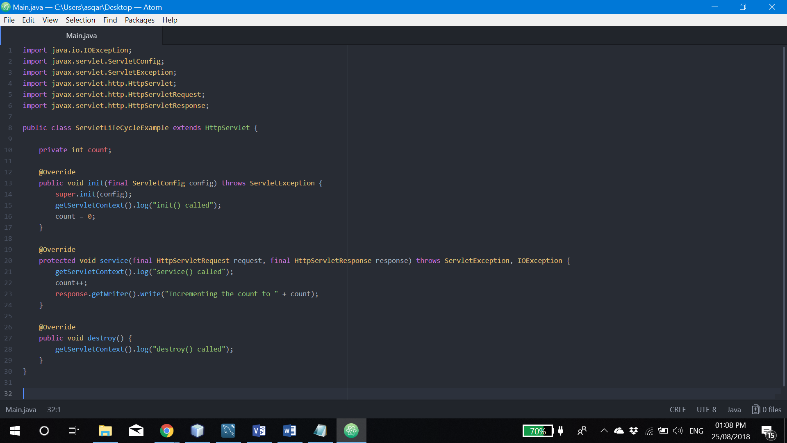

Figure 1.6: Servlet example

### 2.1.3. Diagram

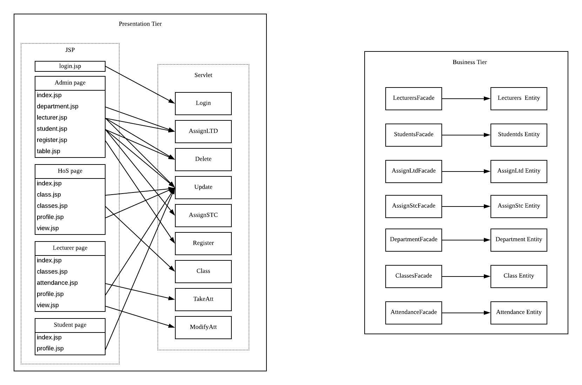

Figure 1.7: Presentation tier diagram

Figure 1.7. represents the architecture of presentation tier and relationship between JSP and servlets in my assignment.

## 2.2. Admin

### 2.2.1. Login

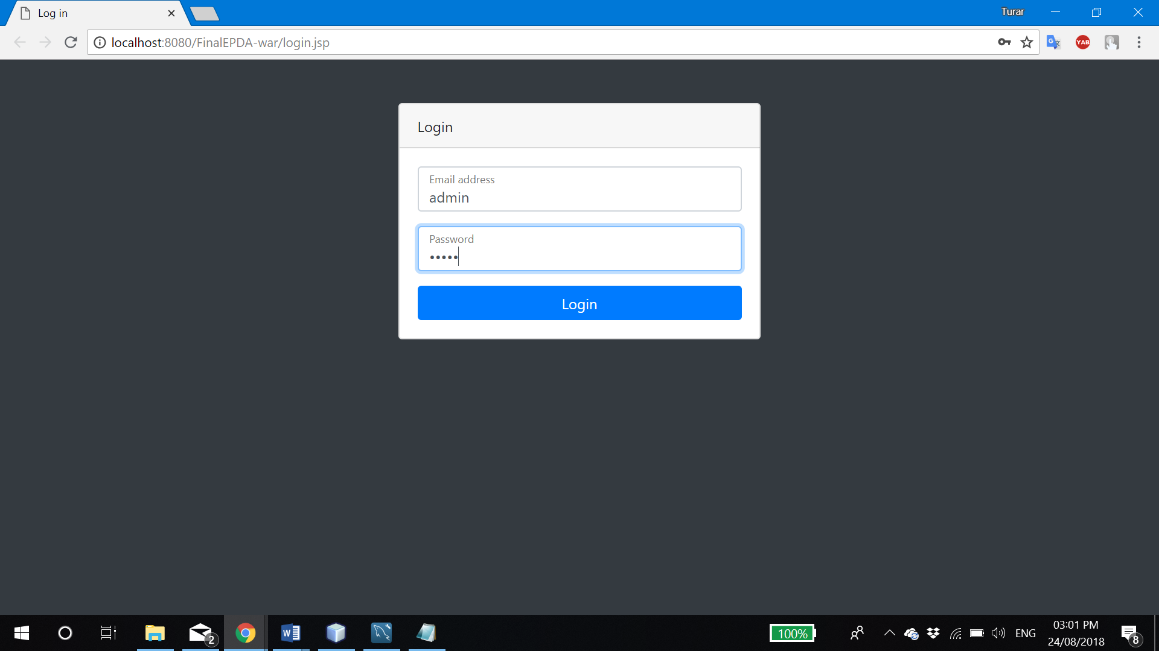

Figure 2.1: Admin login

Admin can be logged in by using default username and password (admin:admin). Once user clicked “Login” button, entered information will be passed to the Login servlet to process it (Figure 2.2. Line 54-59).

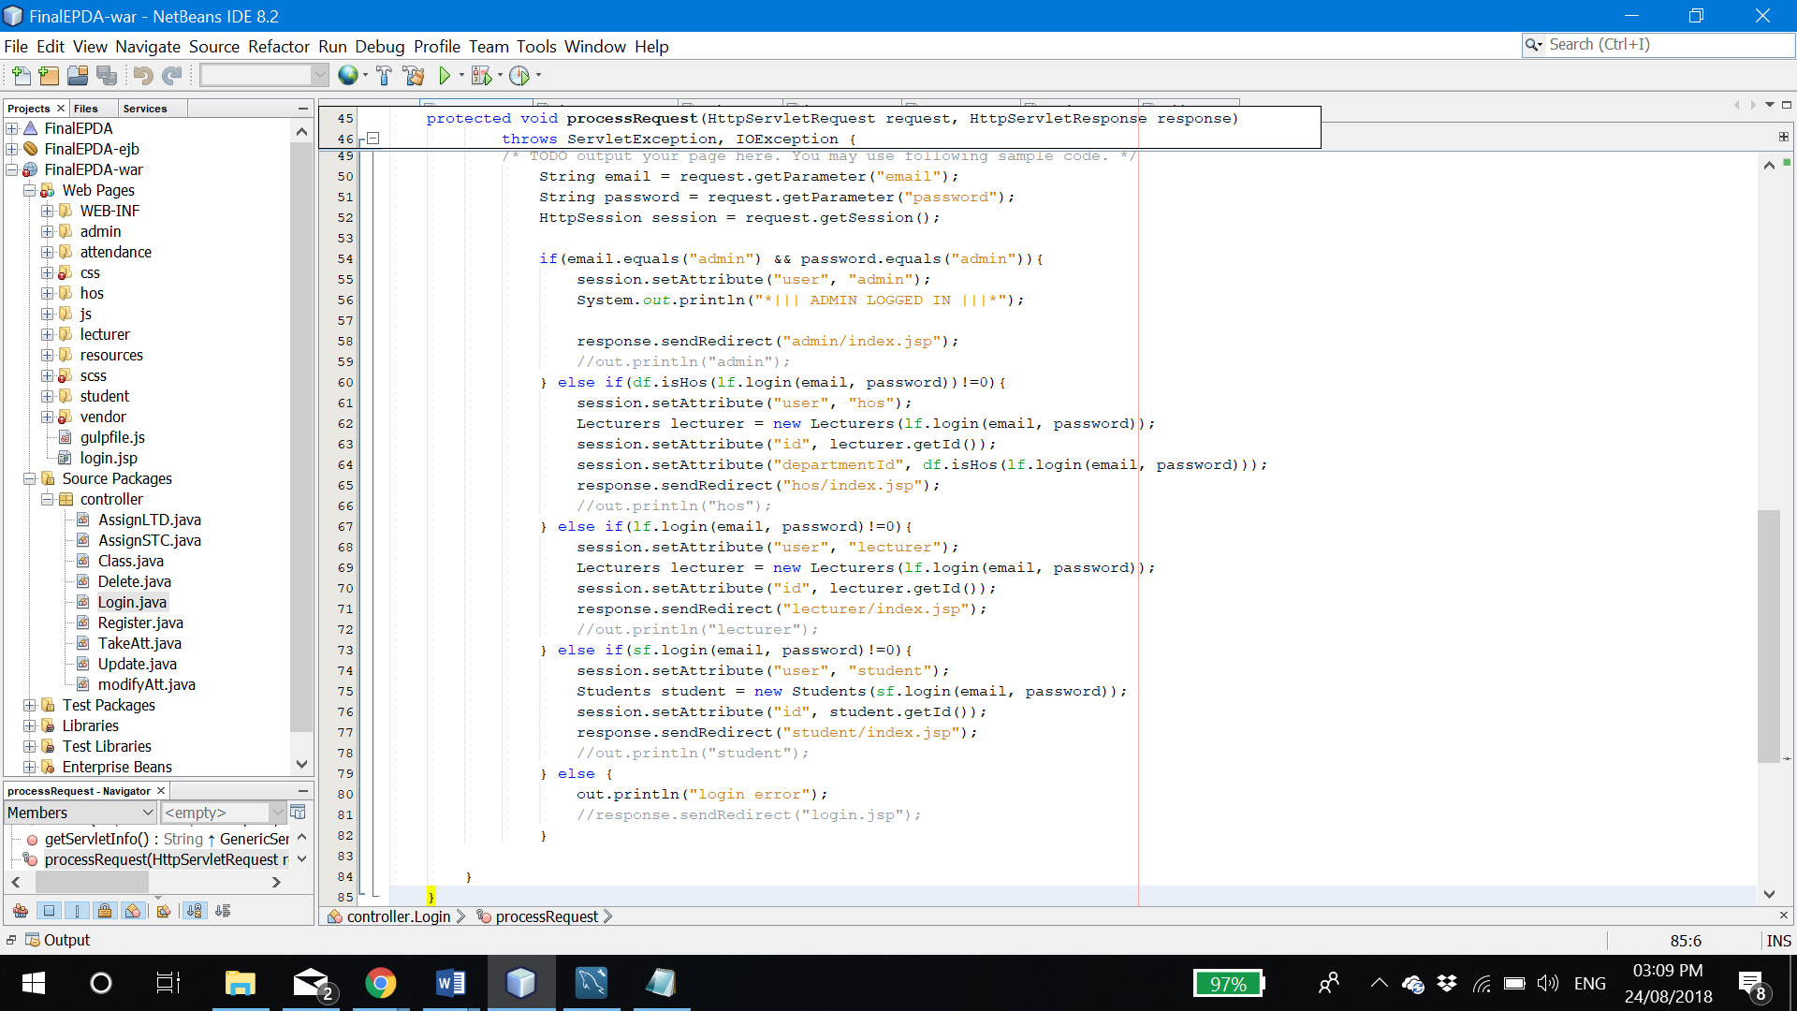

Figure 2.2: Login servlet

It will check if entered username and password satisfies admin’s login account, and if it does, servlet will set session ‘user’ attribute to ‘admin’ variable to be recognized in other pages.

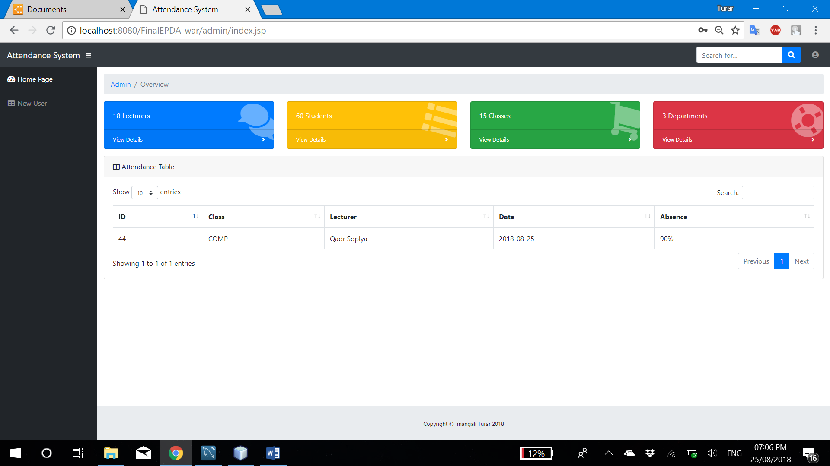

Figure 2.3: Admin main page

Once admin entered right info, Login servlet will resend him to the admin’s home page ‘admin/index.jsp’.

### 2.2.2. Register new user

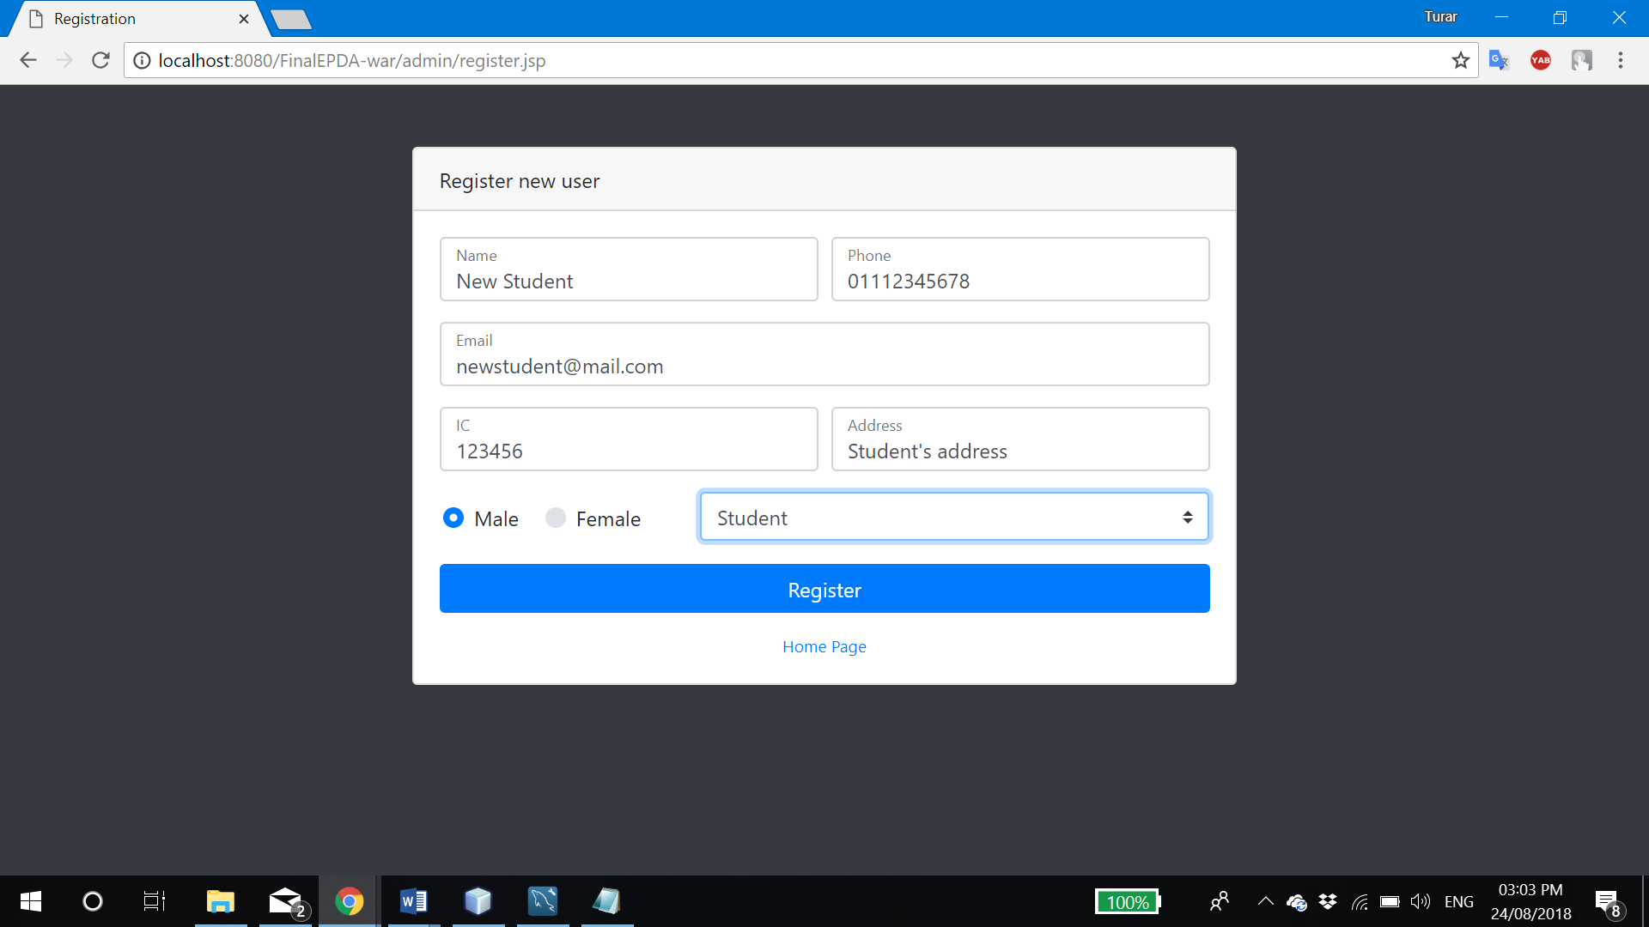

Figure 2.4: Student registration page

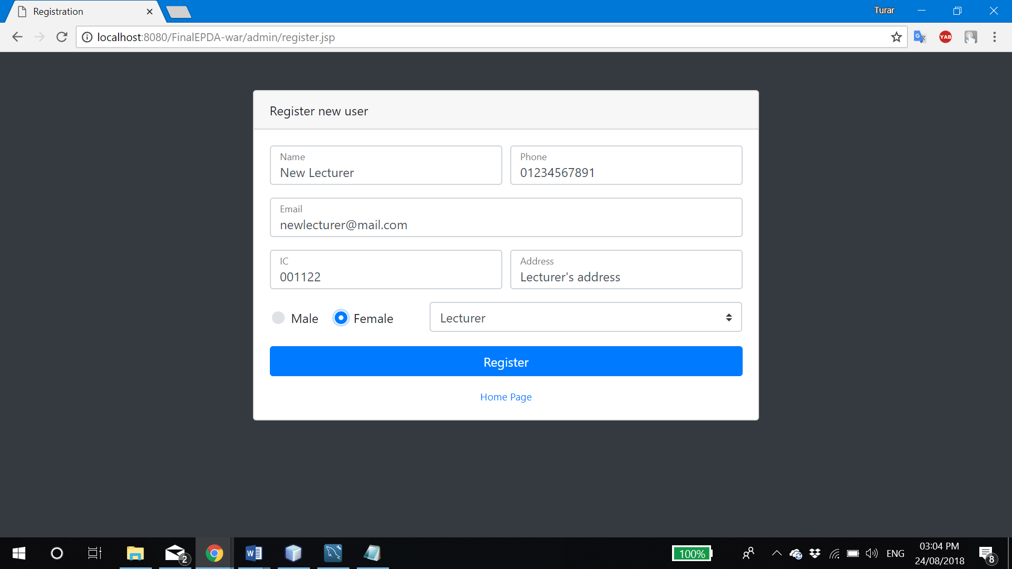

Figure 2.5: Lecturer registration page

In ‘admin/registration.jsp’ page, admin is able to register new lecturer or student to the system.

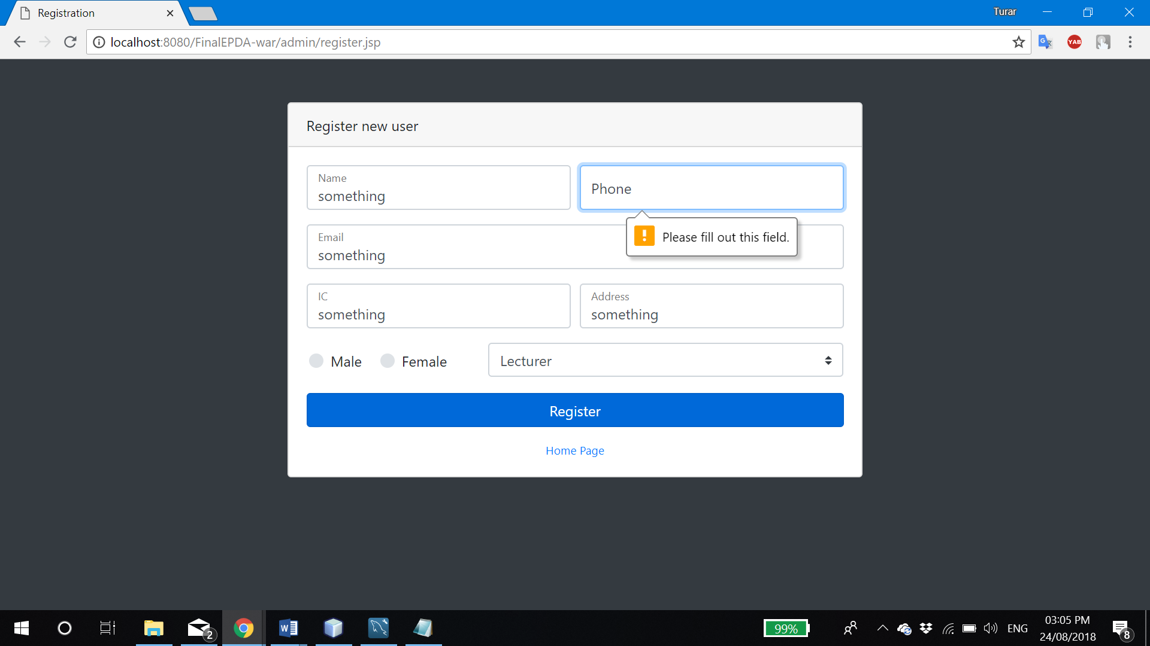

Figure 2.6: Registration validation

If user not entered necessary information and click ‘Register’, page will not proceed forward, but will notify and ask user to fill up inputs with valid information.

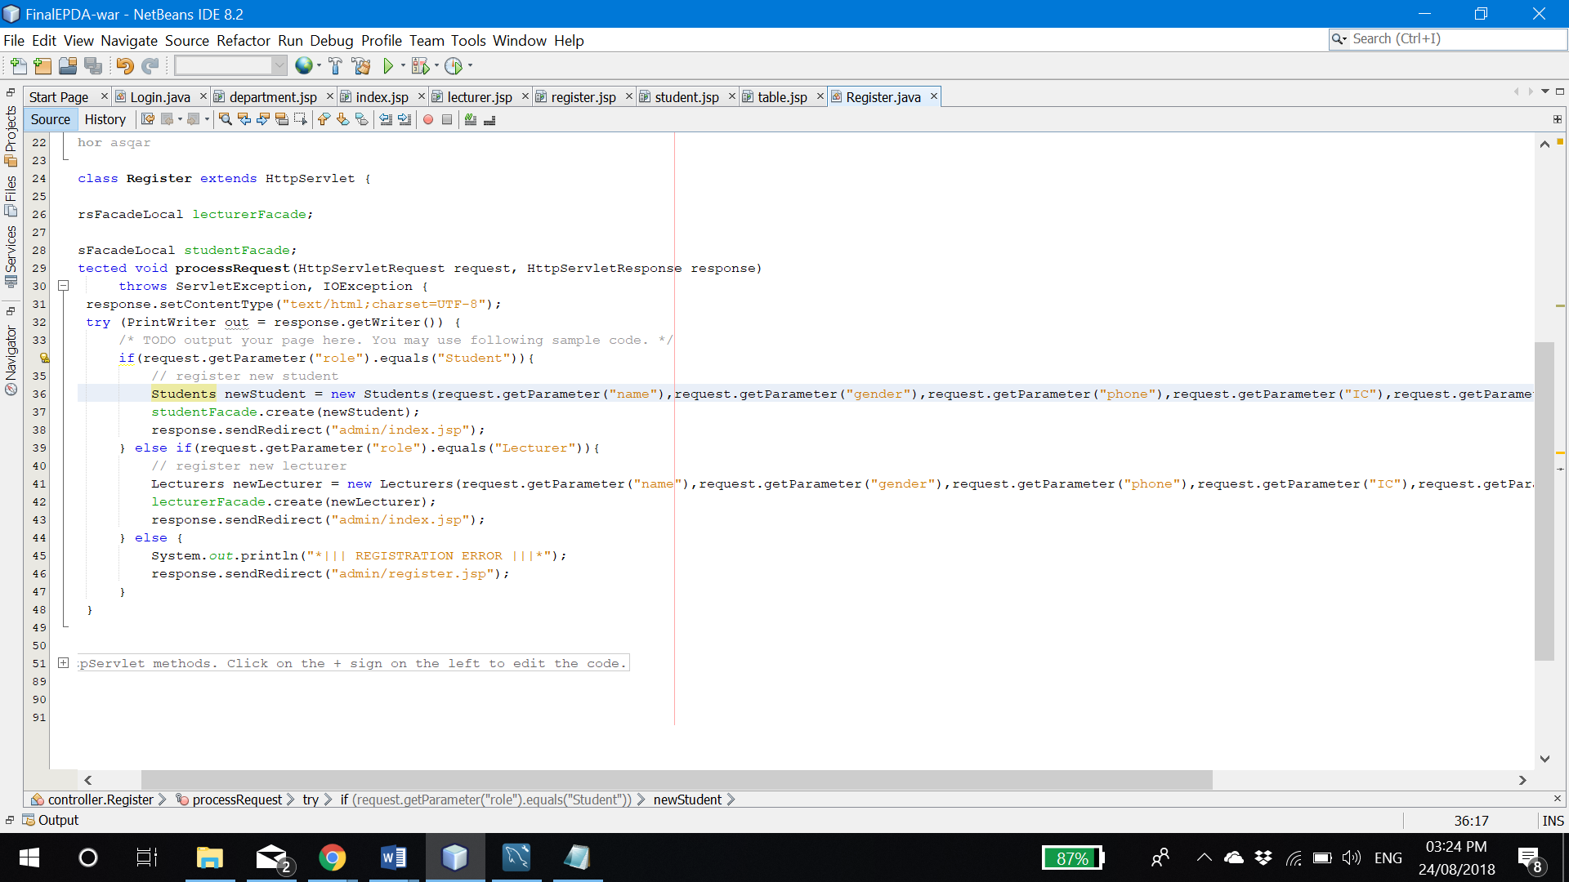

Figure 2.7: Register servlet

After admin filled inputs and clicked ‘Register’, entered inputs will be passed to the ‘Register’ servlet by POST request and create new user.

### 2.2.3. Update, search, delete users

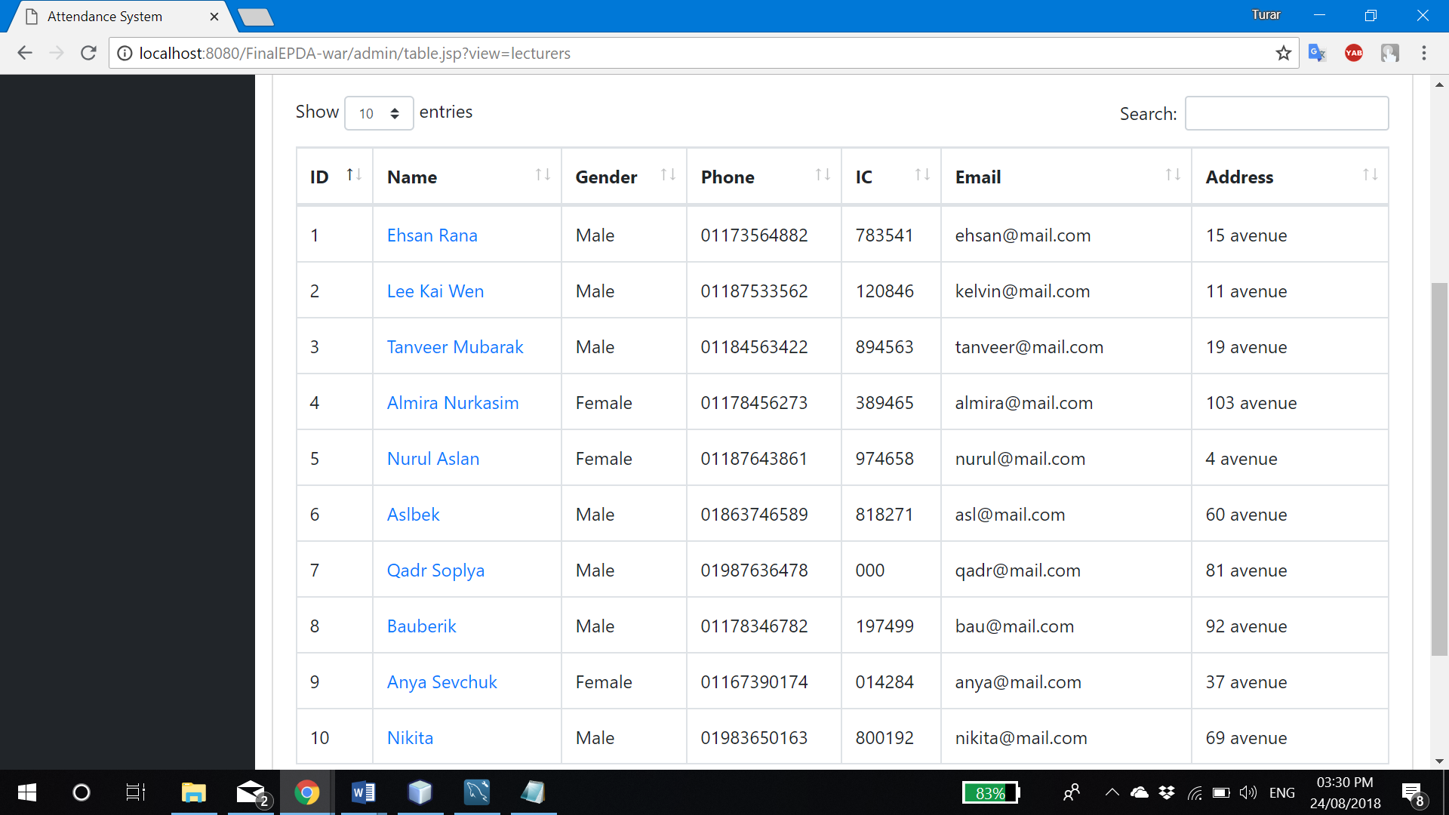

Figure 2.8: List of students/lecturers

In ‘admin/table.jsp’ admin is able to see a list of lecturers (?view=lecturers) or students (?view=students). Each name is in <a> HTML tag and is referring to the page of its account by passing ‘ID’ of user through GET request.

Pagination is implemented to better view. Admin also can customize how many rows in one page should appear.

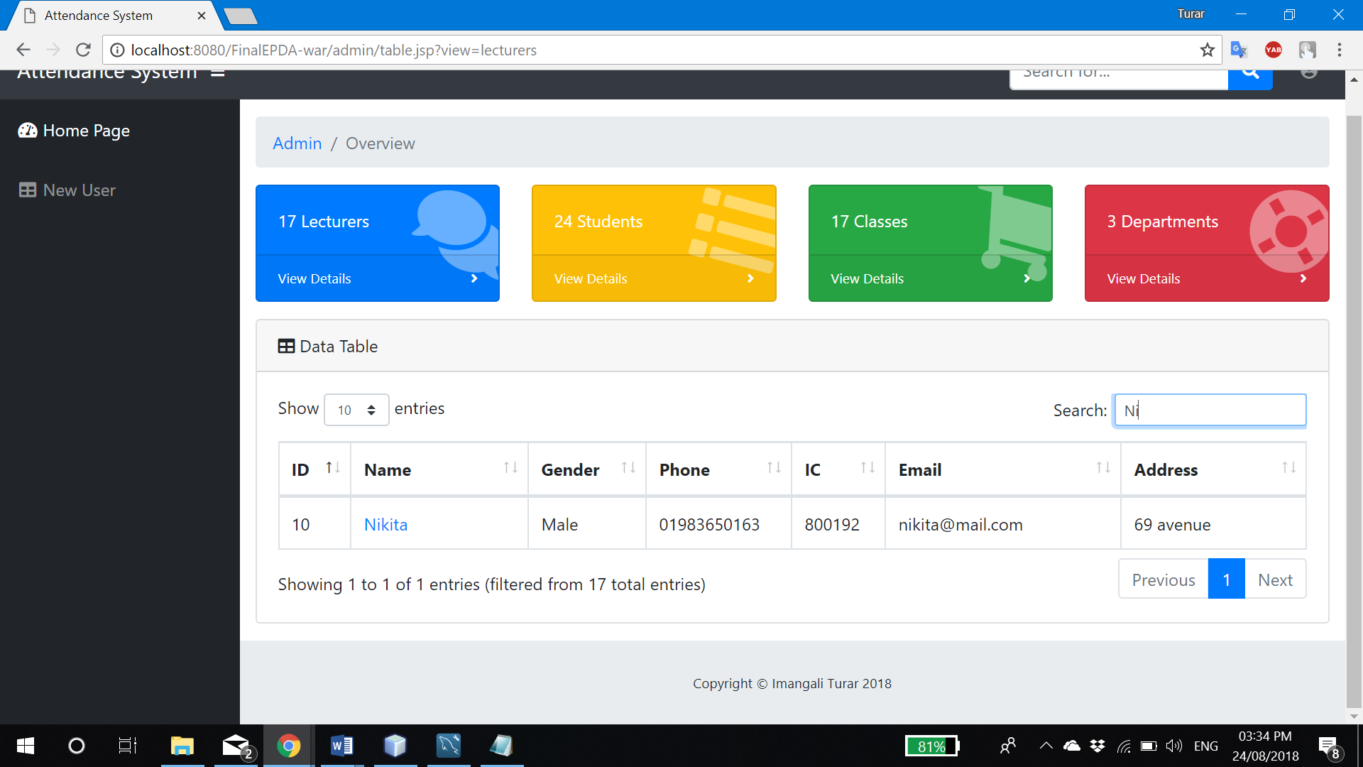

Figure 2.9: User search

In the top-right corner of table, admin can make dynamic search of users in the table.

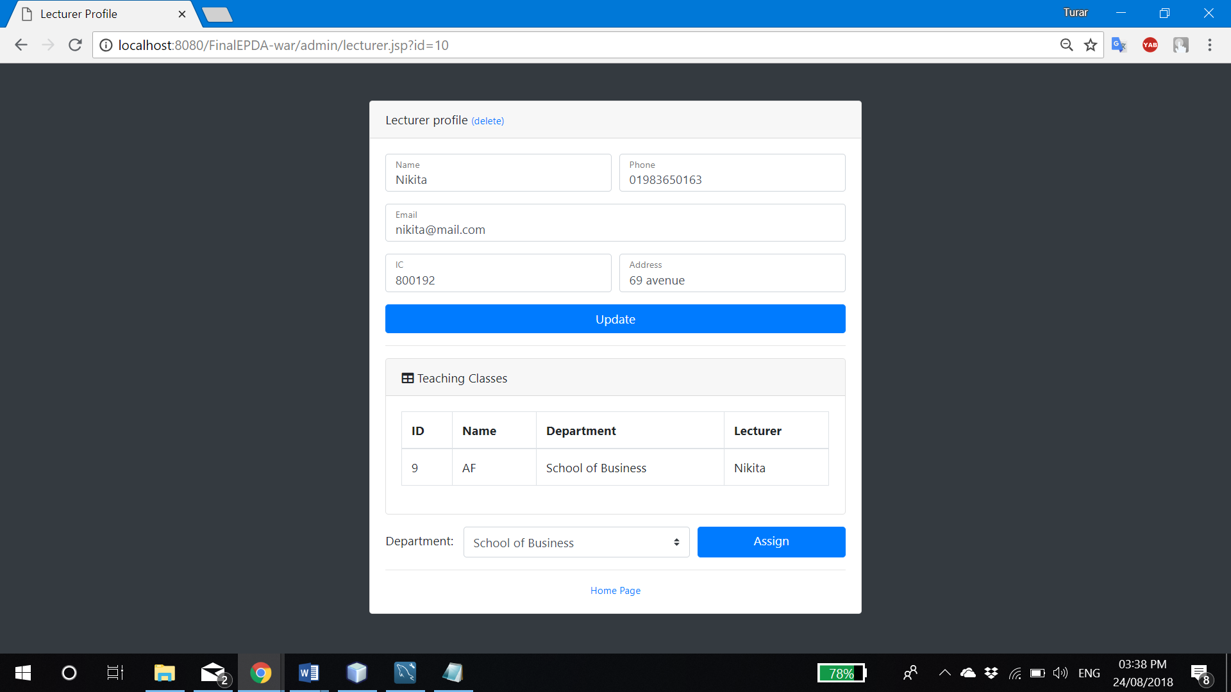

Figure 2.10: Lecturer profile

In ‘admin/lecturer.jsp’ or ‘admin/student.jsp’ admin is able to see user’s account detail by passing ‘ID’ (as well as additional information which is in letter discussion). There are also buttons to update and delete user.

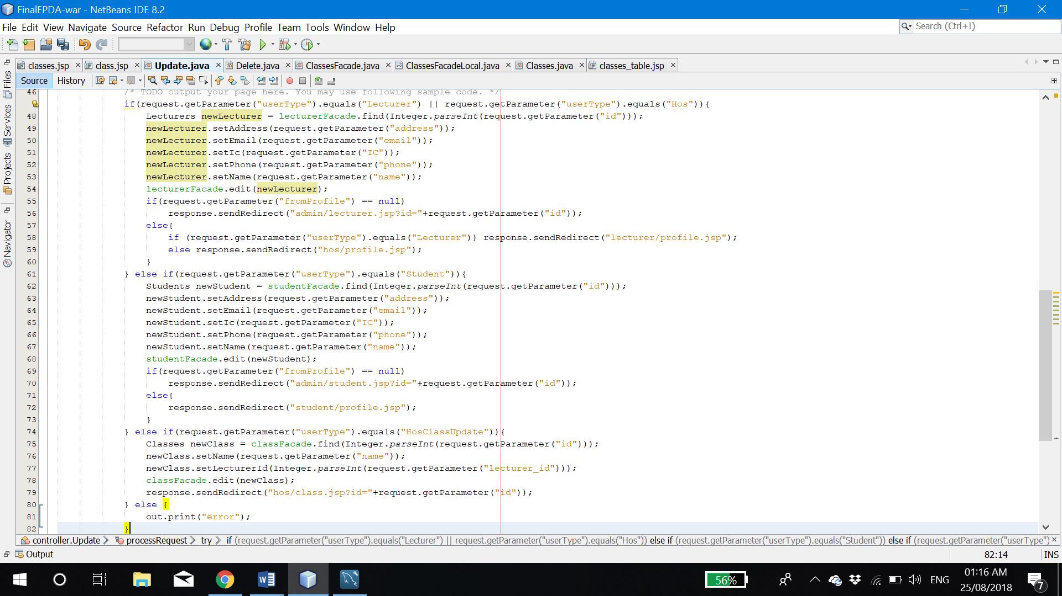

2.11: Update servlet

When admin clicked ‘Update’ in profile page, it will pass all inputs to the ‘Update’ servlet which will make new object of that user by passing ‘ID’ which is unique number of users. Once object is identified, using getters we will change all attributes to new ones, and then, edit by our EJB.

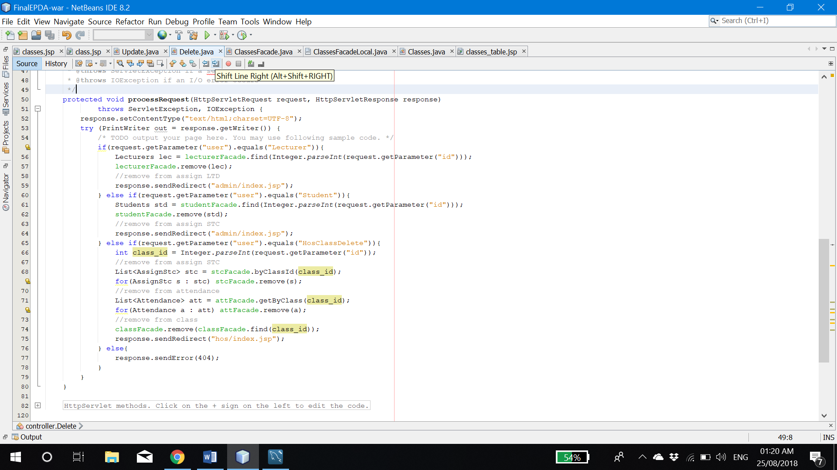

Figure 2.12: Delete servlet

‘Delete’ servlet will get ‘ID’ of user, and base on that unique number, search and remove certain user from our database.

### 2.2.4. Assign lecturer to department

As you saw in Figure 2.10. admin is able to see the department to which lecturer is currently assigned. To update that, admin must simply choose new department from selection menu and click ‘Assign’.

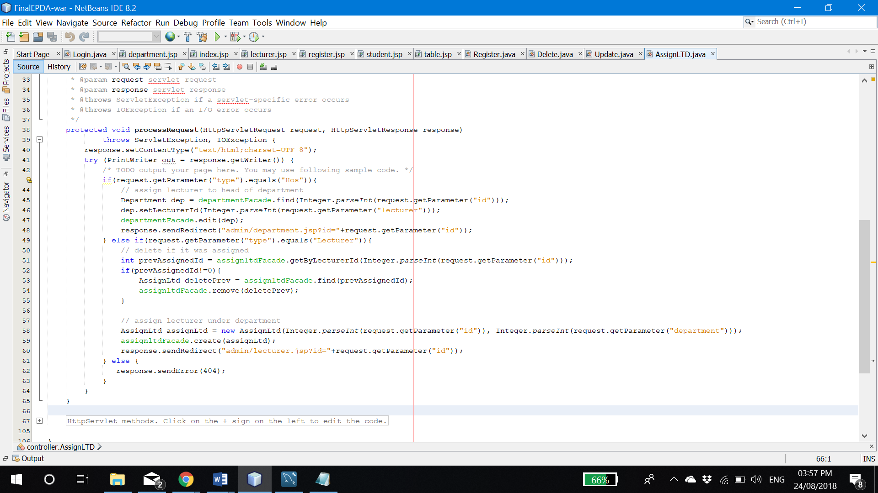

Figure 2.13: AssignLTD servlet

In Figure 2.13, at line 51-60 I used to implement assignment of lecturer to the department. And for validation reason, before that, I had to remove previous assigned row from database.

### 2.2.5. Student’s attendance and classes

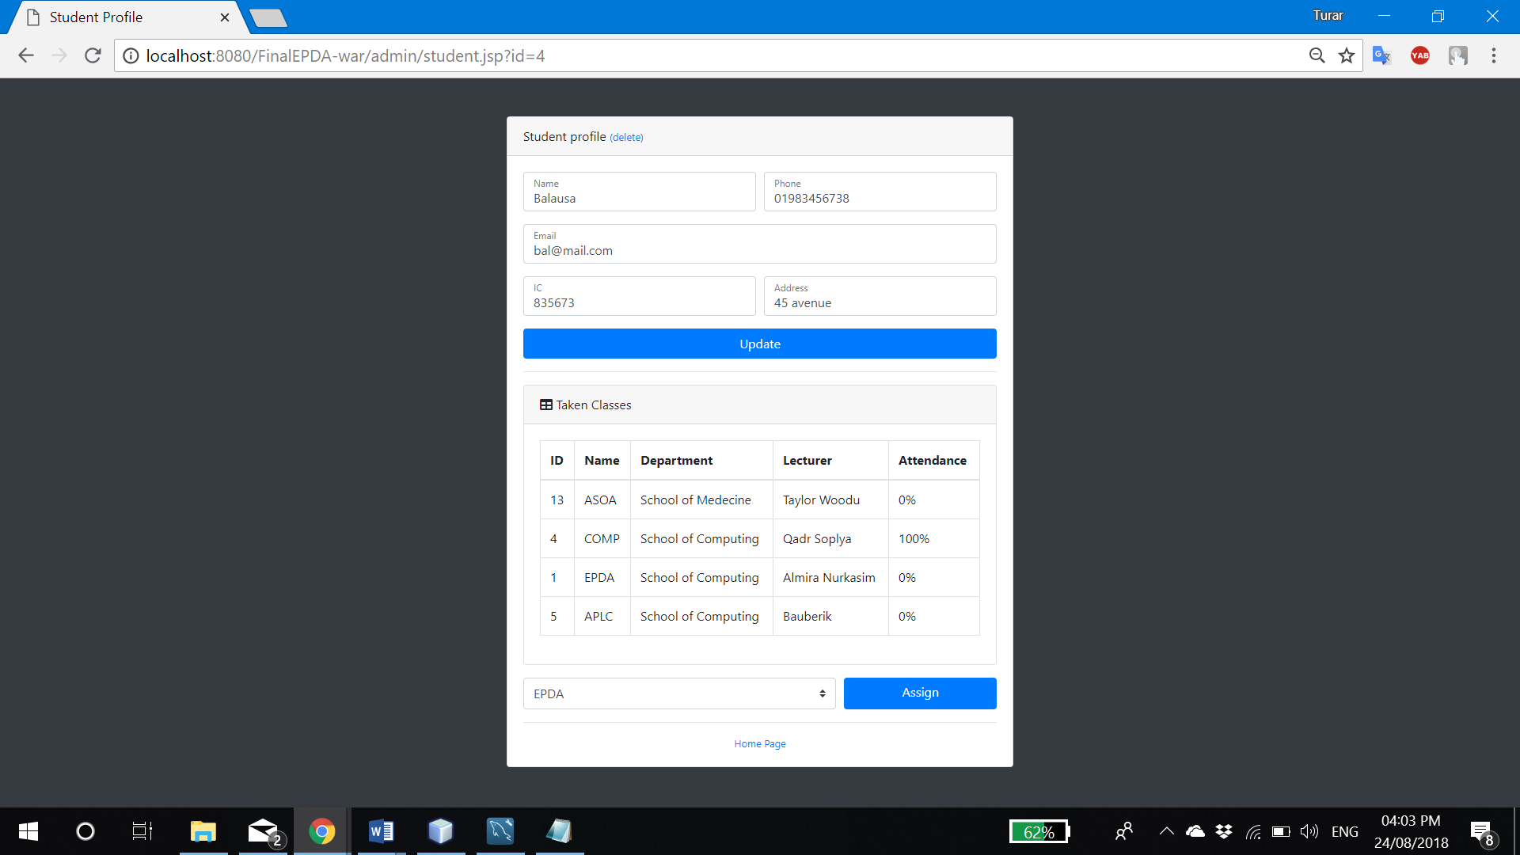

Figure 2.14: Student’s profile page

In the profile page of students, admin is able to see attendance percentage of all classes student is taking. The formula to calculate percentage is **[percentage = (present classes * 100)/total classes].**

Below that, you can see the list of all classes available. Choosing any of them, and clicking ‘Assign’, student will be assigned to that class.

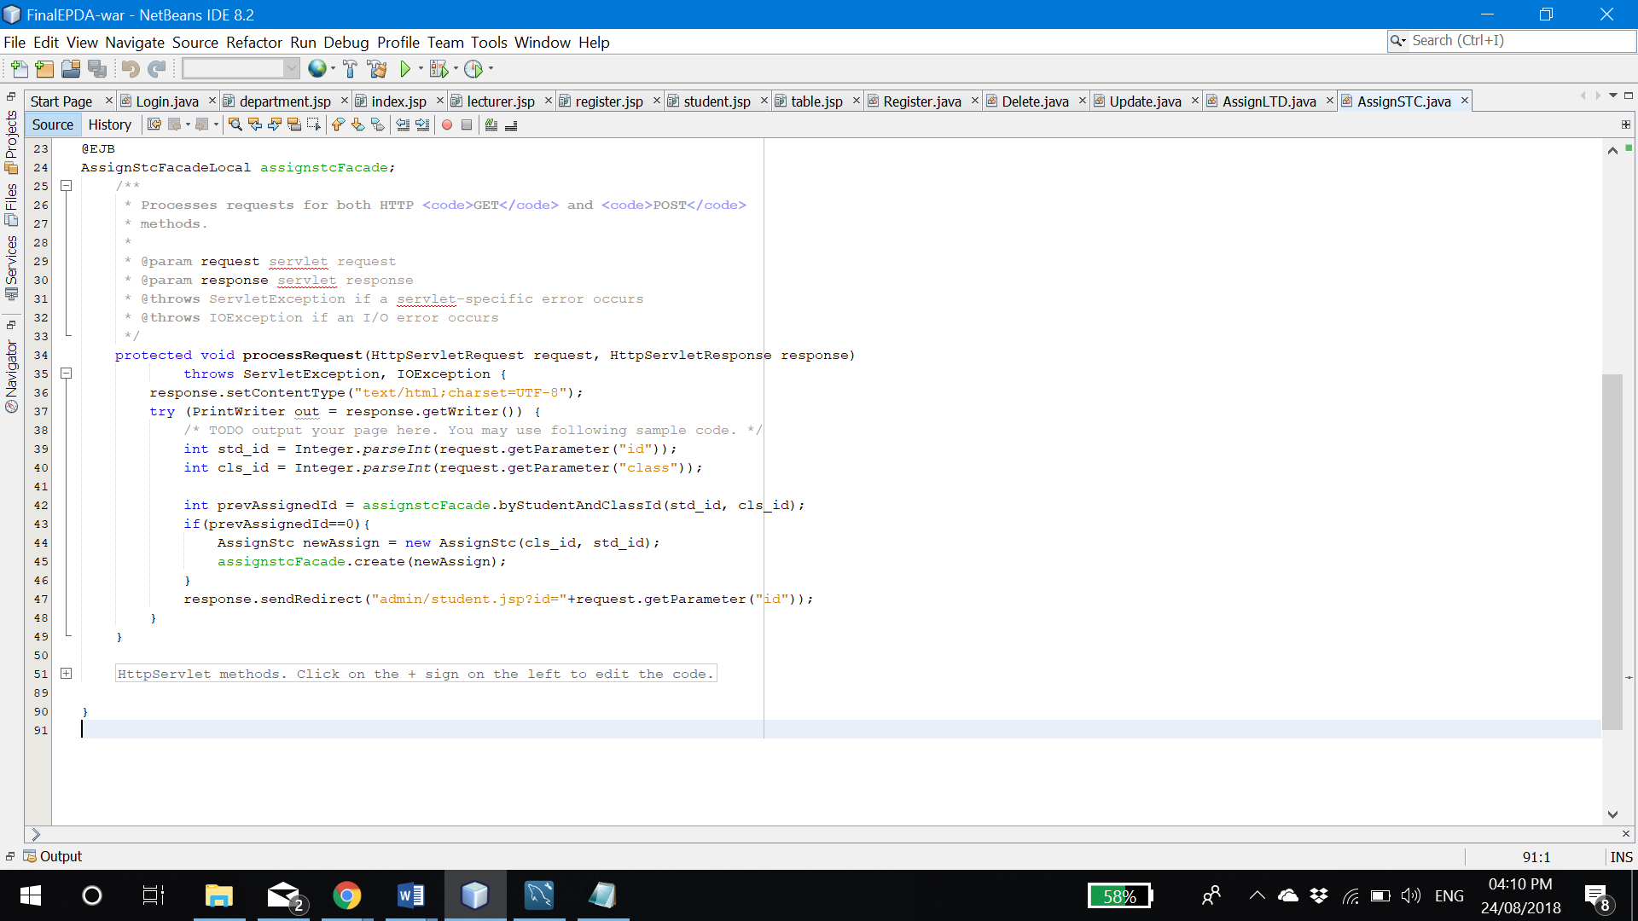

Figure 2.15: AssignSTC servlet

Assigning student to the new class is processing in ‘AssignSTC’ servlet. If student is already assigned to that class, assigning will be just ignored.

### 2.2.6. Additional features

#### 2.2.6.1. Count of all classes, departments, lecturers and students

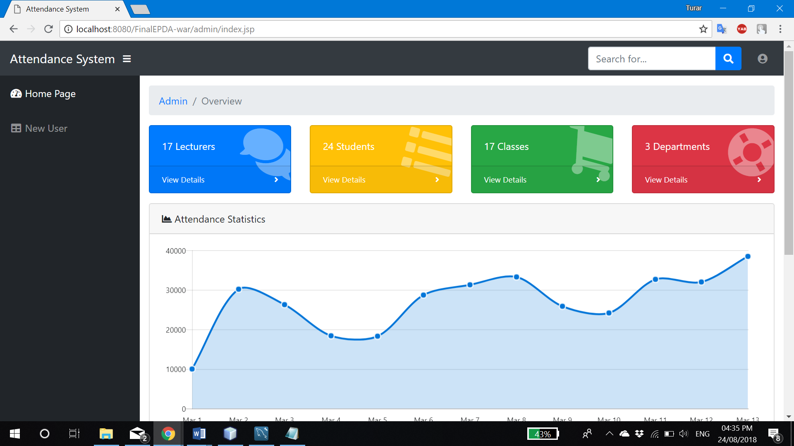

Figure 2.16: Statistics

First additional report is counting of number of lecturers, students, classes and departments. The purpose of that report is to get better understanding of running system in term of resource management.

The JSP code is located in ‘admin/layout/inocard.jsp’ and included to every pages of admin by **<jsp:include page=’layout/inocard.jsp’>**

#### 2.2.6.2. Attendance report by classes

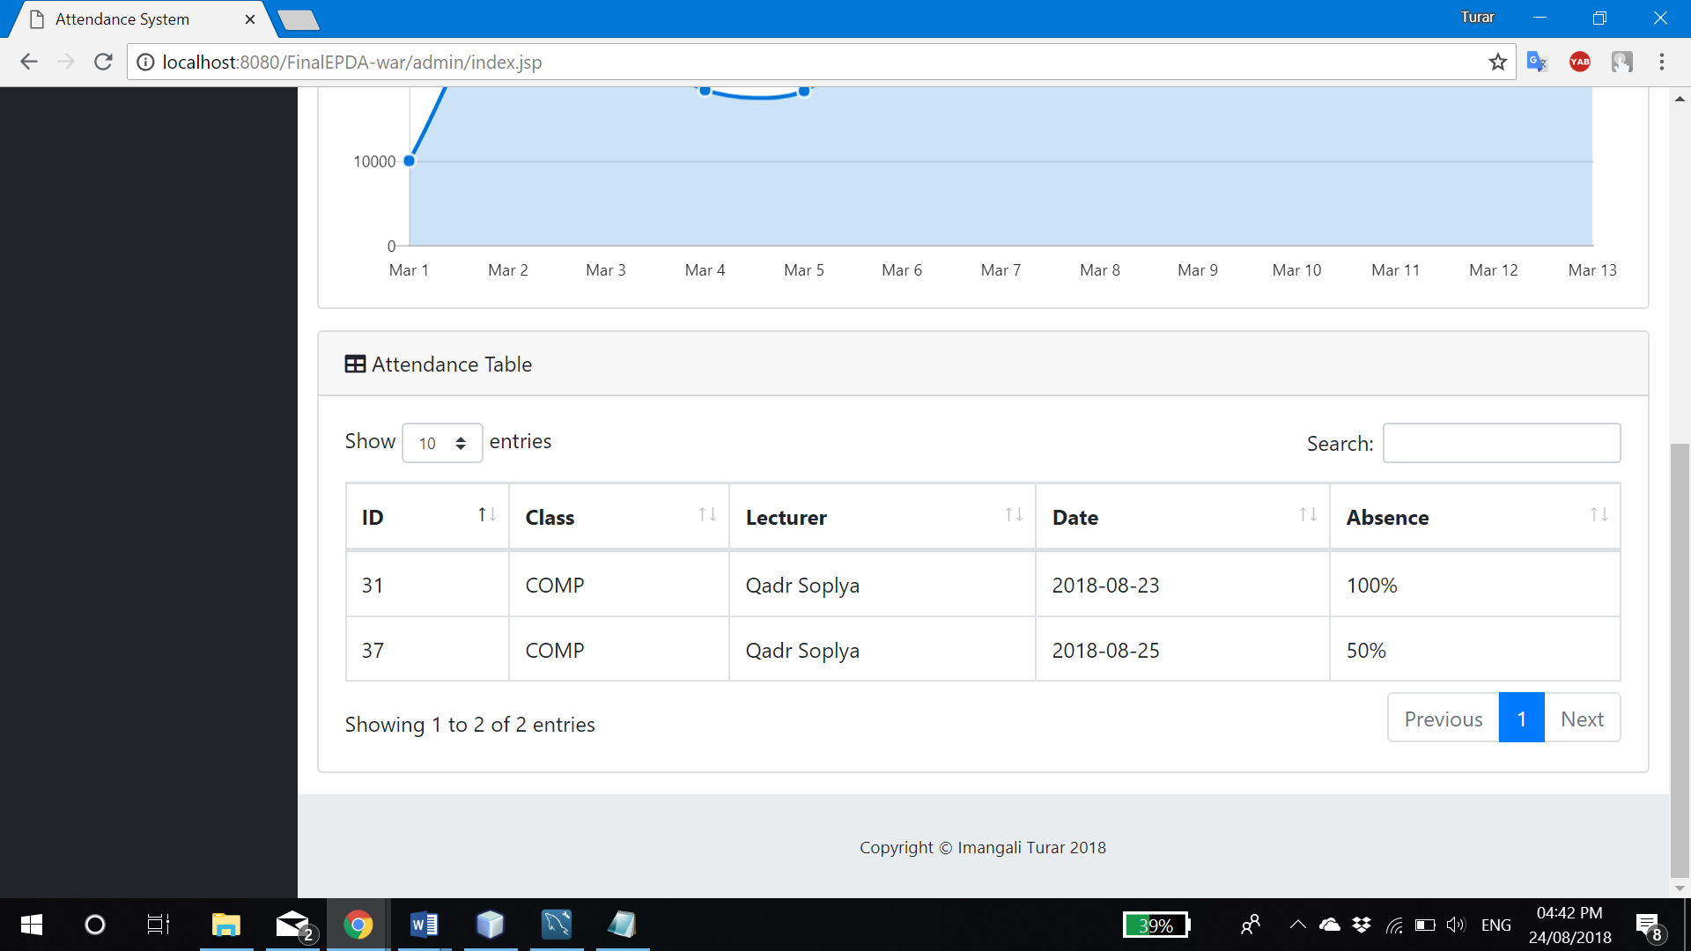

Figure 2.17: Class attendance

Table above shows the percentage of absence in each class, sorter by date. Also, admin is able to make customer sort like sort by percentage of absence to see at which class the worst attendance. Search by every column as lecturer or class is also available to admin.

#### 2.2.6.3. Class list

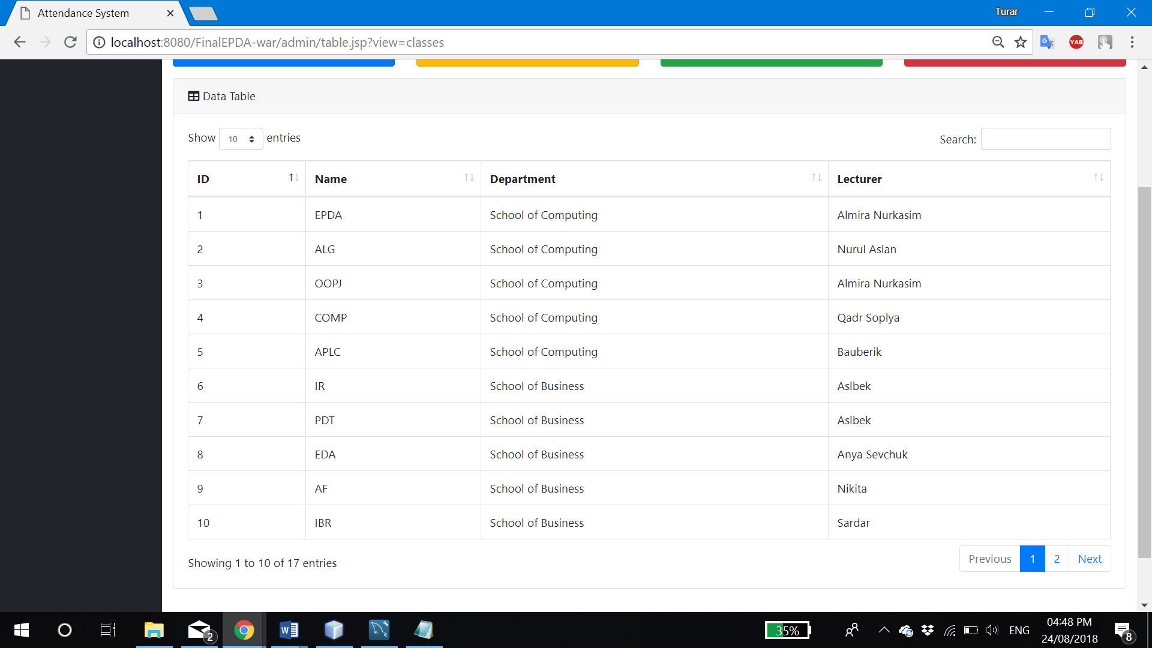

Figure 2.18: Class list

Class list shows all available classes of system, its department and leading lecturer. Search by every column is available.

#### 2.2.6.4. Department list

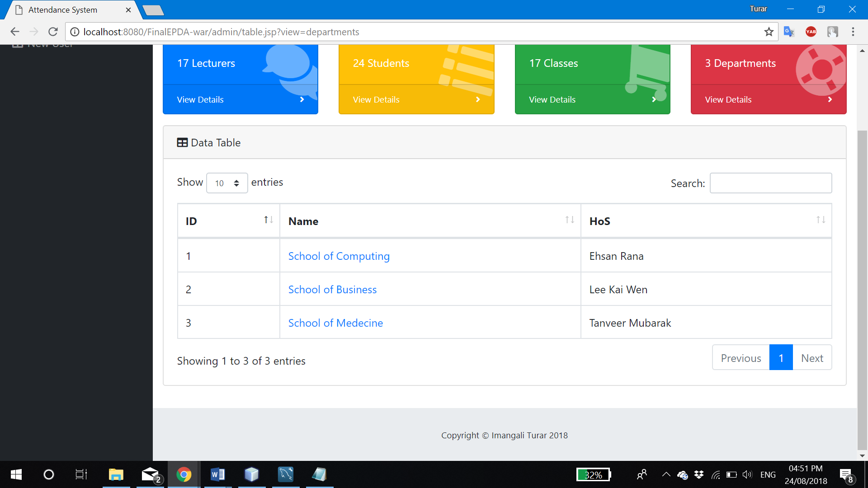

Figure 2.19: Department list

Department list displays all department with its head of department. Every department’s name is in <a> tag, which is referring to the department’s detail (Figure 2.20).

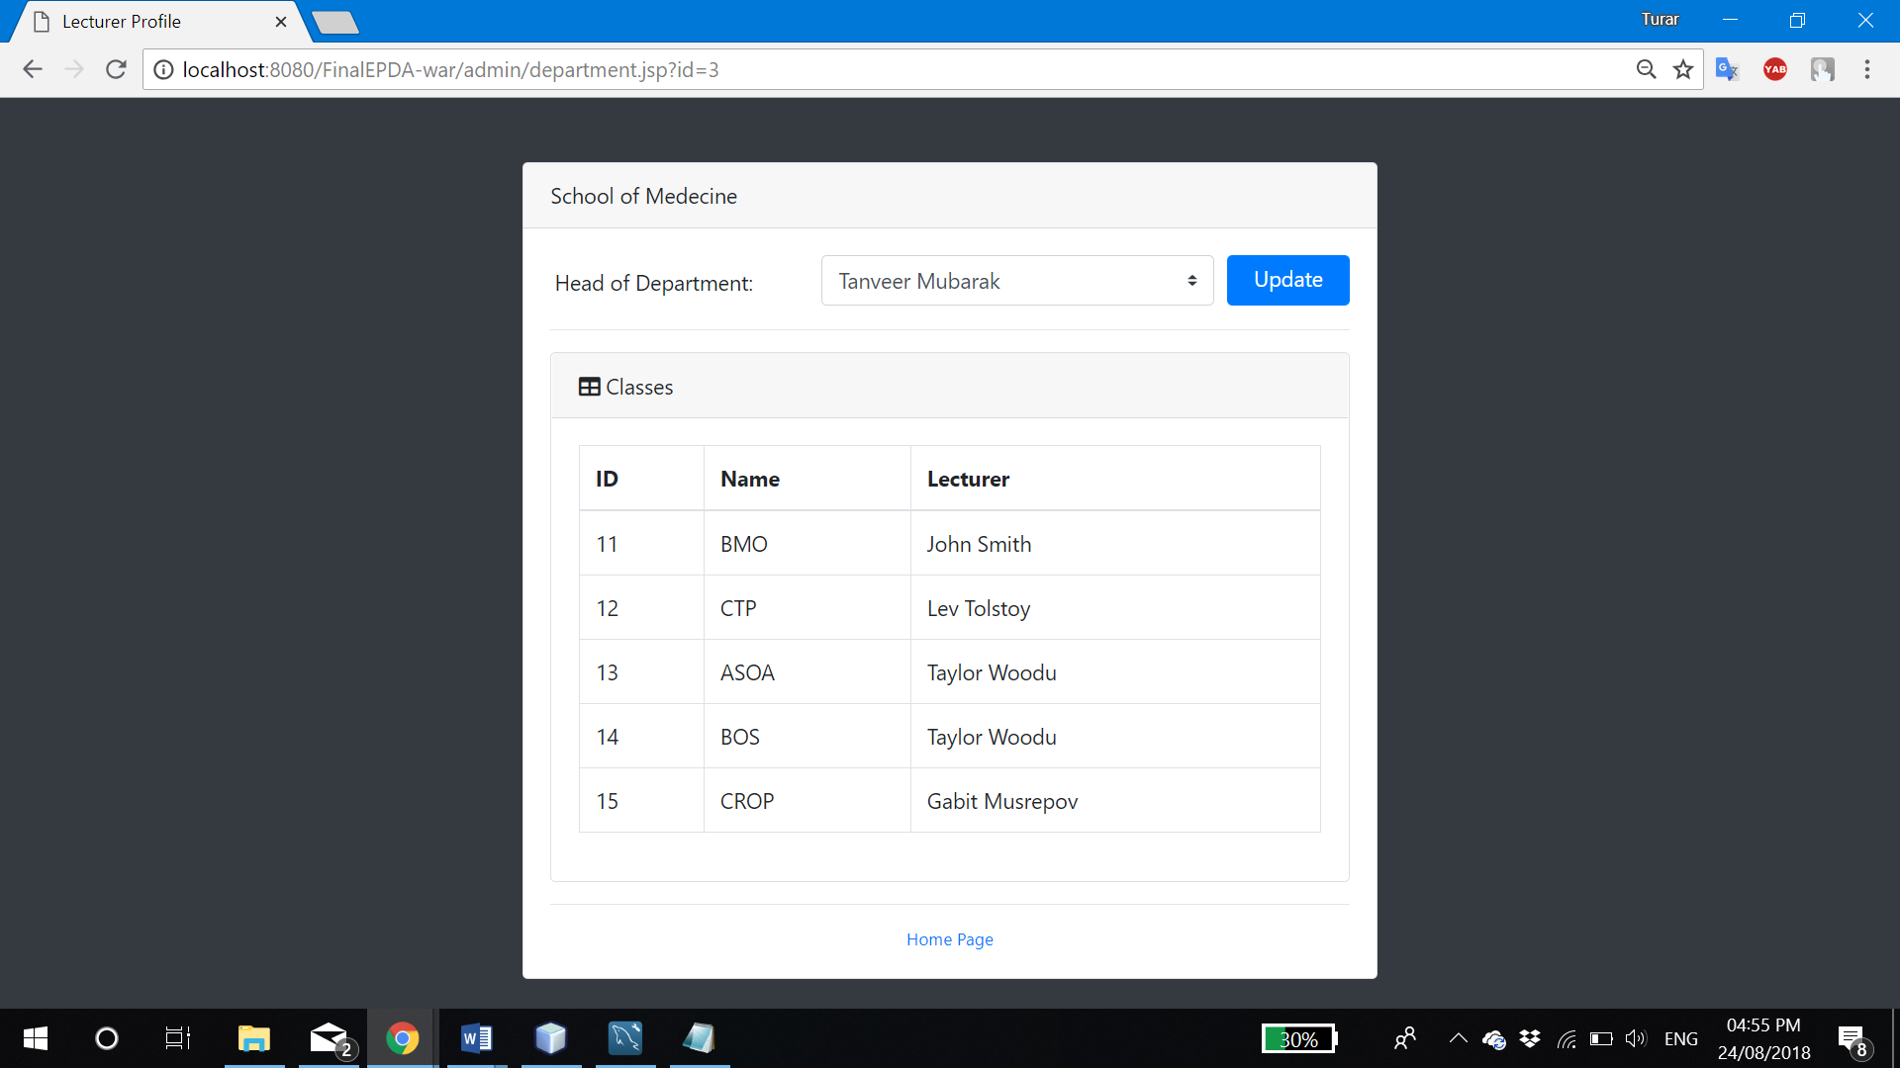

Figure 2.20: Department’s detail

At ‘admin/department.jsp?id=**[department’s ID]**’ admin can see who is a head of that department, if admin wishes, he is able to change him by choosing particular lecturer and click ‘Update’. At the table below, admin can see all classes and its lecturers under that department.

#### 2.2.6.5. Assign HOS to department

As I said above, in Figure 2.20, we can change the head of school, by clicking ‘Update’ button. It will make POST request to the “AssignLTD” servlet, as in Figure 2.13. at line 45-48.

## 2.3. Head of School

### 2.3.1. Login

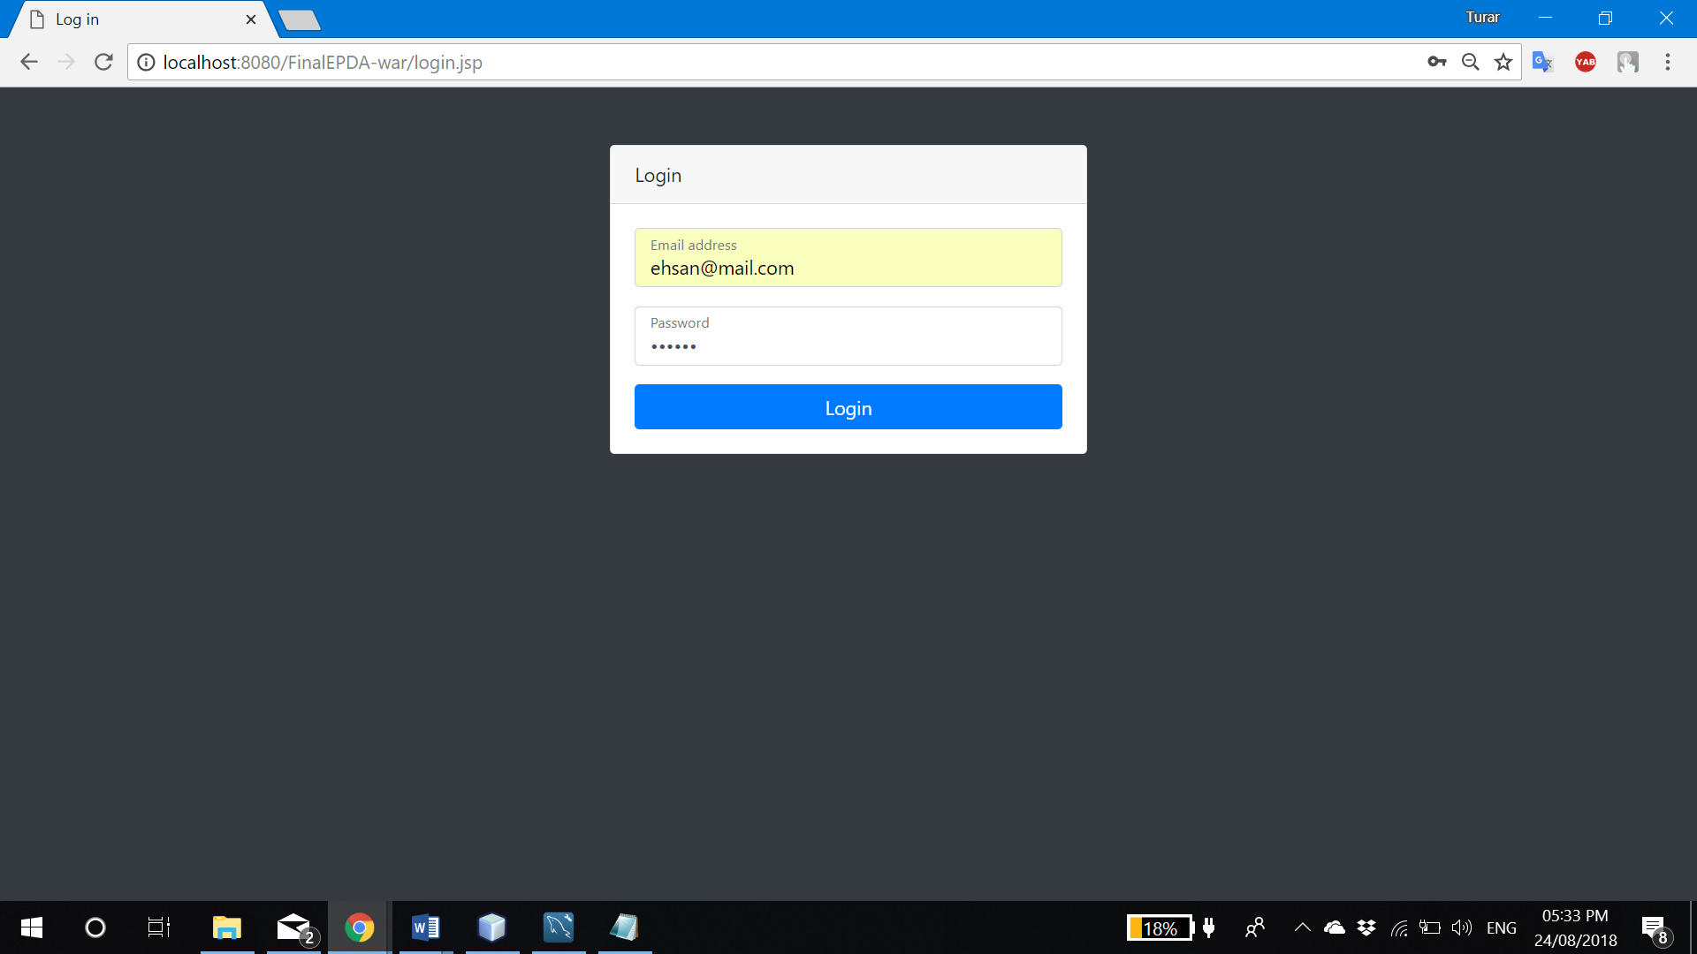

Figure 2.21: HoS login

HoS can be logged in by using its email as a username and IC number as password. Once user clicked “Login” button, entered information will be passed to the Login servlet to process it (Figure 2.2. Line 61-65).

It will check if entered username and password satisfies HOS’s login account, and if it does, servlet will set session ‘hos’ attribute to ‘user’ variable to be recognized in other pages as well as his department ID and own ID.

If log in was successful, servlet will resend head of school to its own main page at ‘hos/index.jsp’.

### 2.3.2. Edit profile

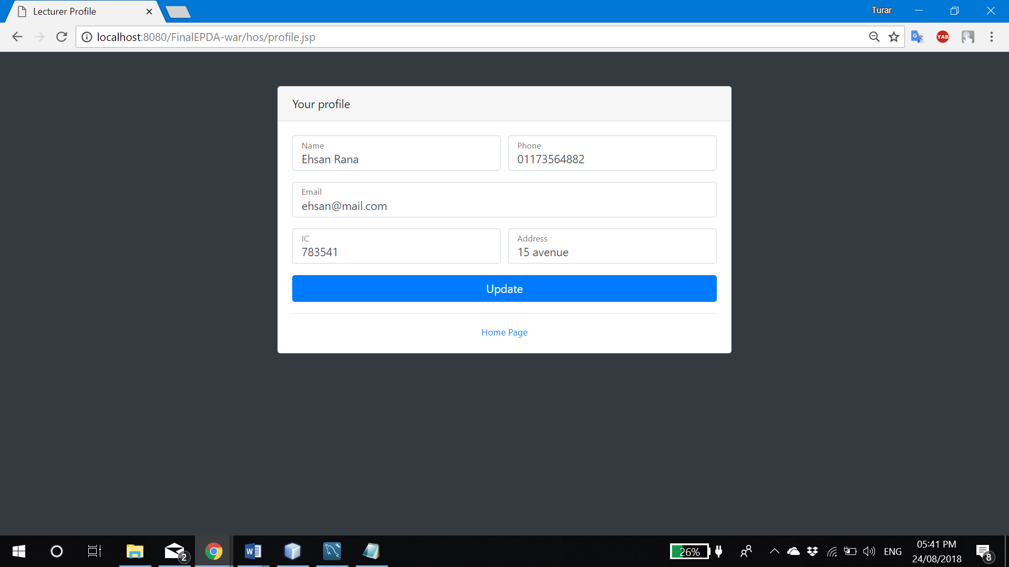

Figure 2.22: Edit HOS profile

At ‘hos/profile.jsp’ user can change own profile information. To make update, user should click “Update” button, and all details will be sent to the “Update” servlet as seen in Figure 2.11 at line 48-60.

### 2.3.3. Create/update/delete class and assign lecturer

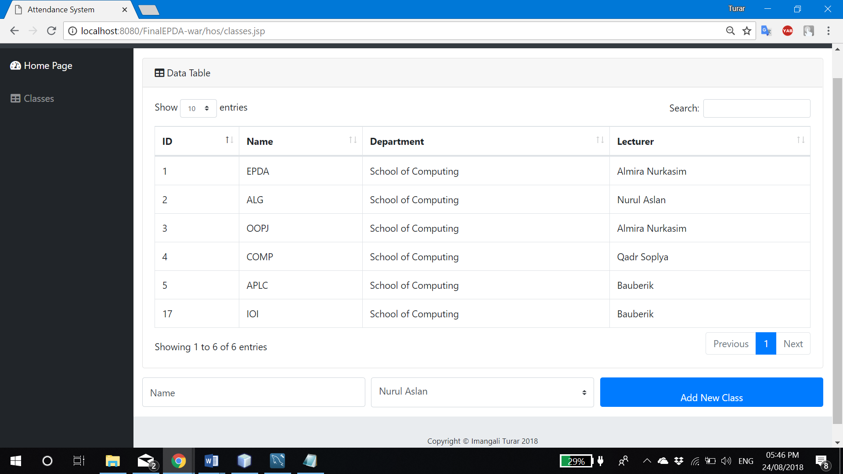

Figure 2.23: Classes under HOS

Page ‘hos/classes.jsp’ is giving opportunity to see all classes which assigned to the HOS’s department. Here you can make search using input box on top-right corner. By clicking on class name, HOS is able to modify or delete certain class.

Below HOS can see the form for creating new class. He can type class name, choose lecturer, which assigned to his department and click ‘Add New Class’ button, which refers to ‘Class’ servlet (Figure 2.24).

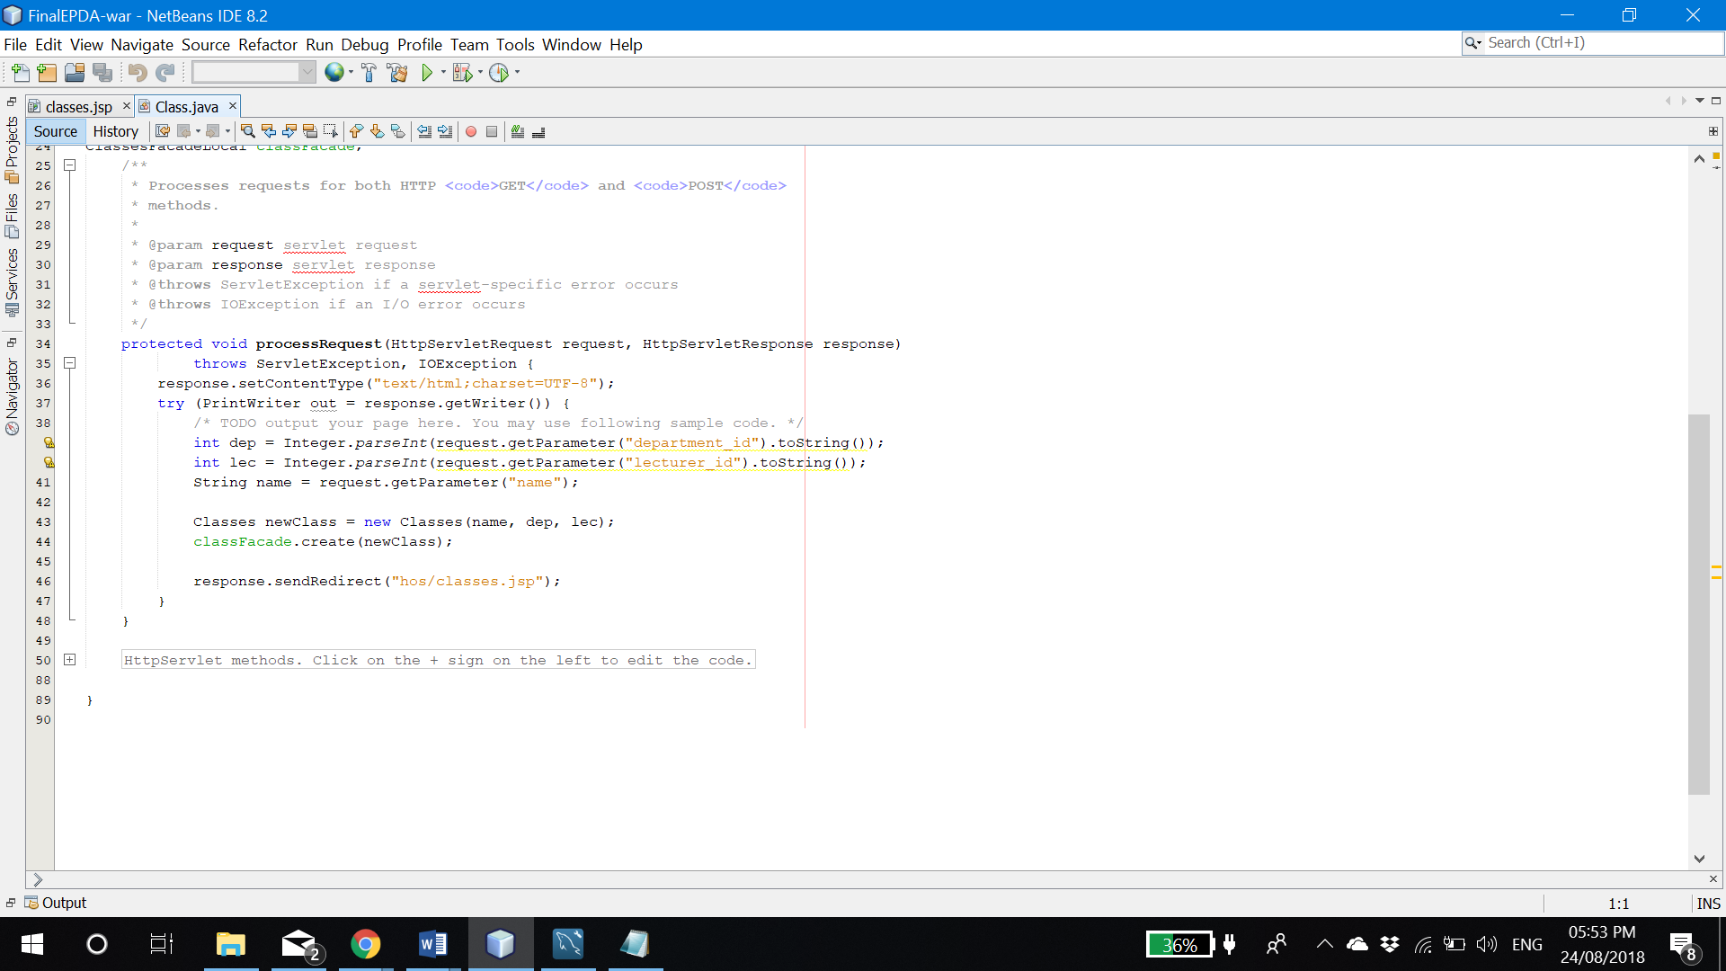

Figure 2.24: Class servlet

At servlet I just created new instance of class and passed it to the EJB which will add that class to database.

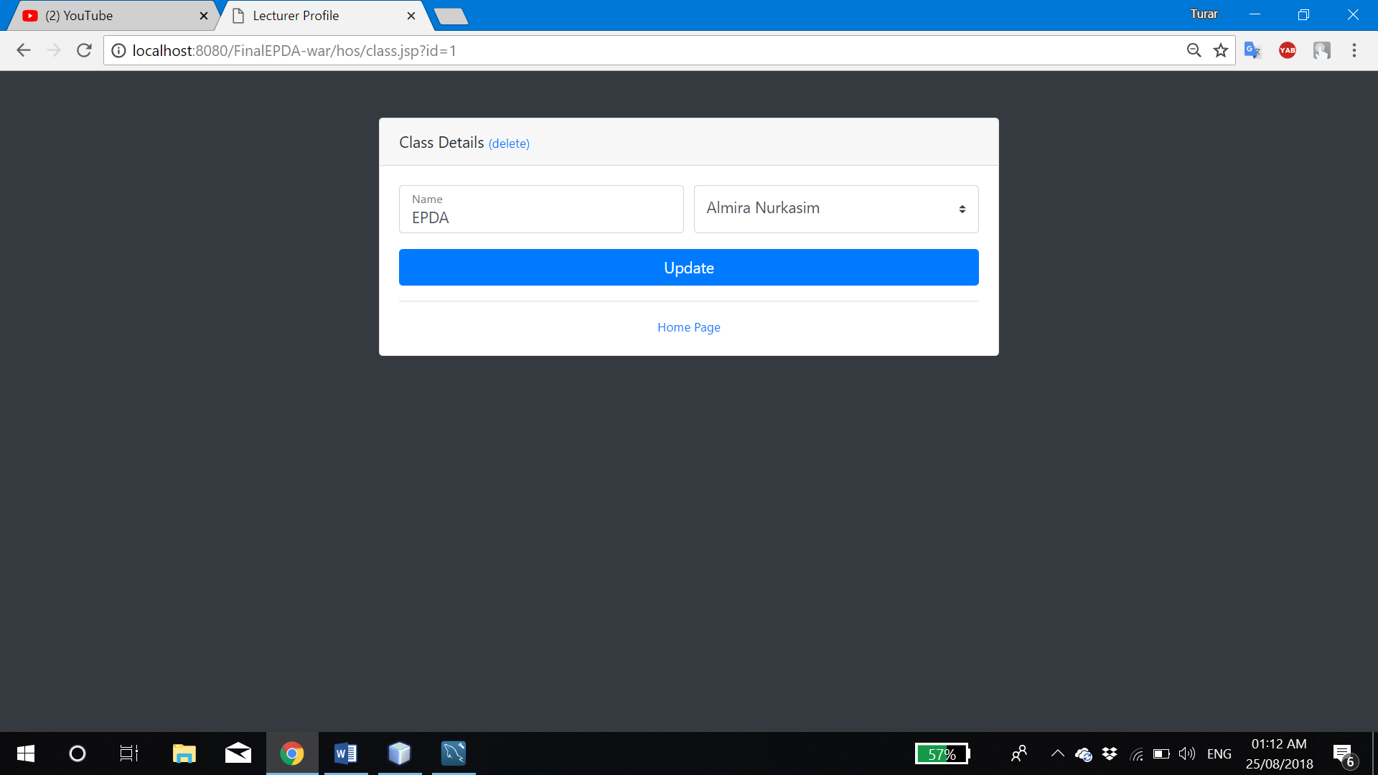

Figure 2.25: Modify/delete page

Page ‘hos/class.jsp?id=**[class ID]**’ provides modification and removing particular class from the system.

### 2.3.4. View attendance

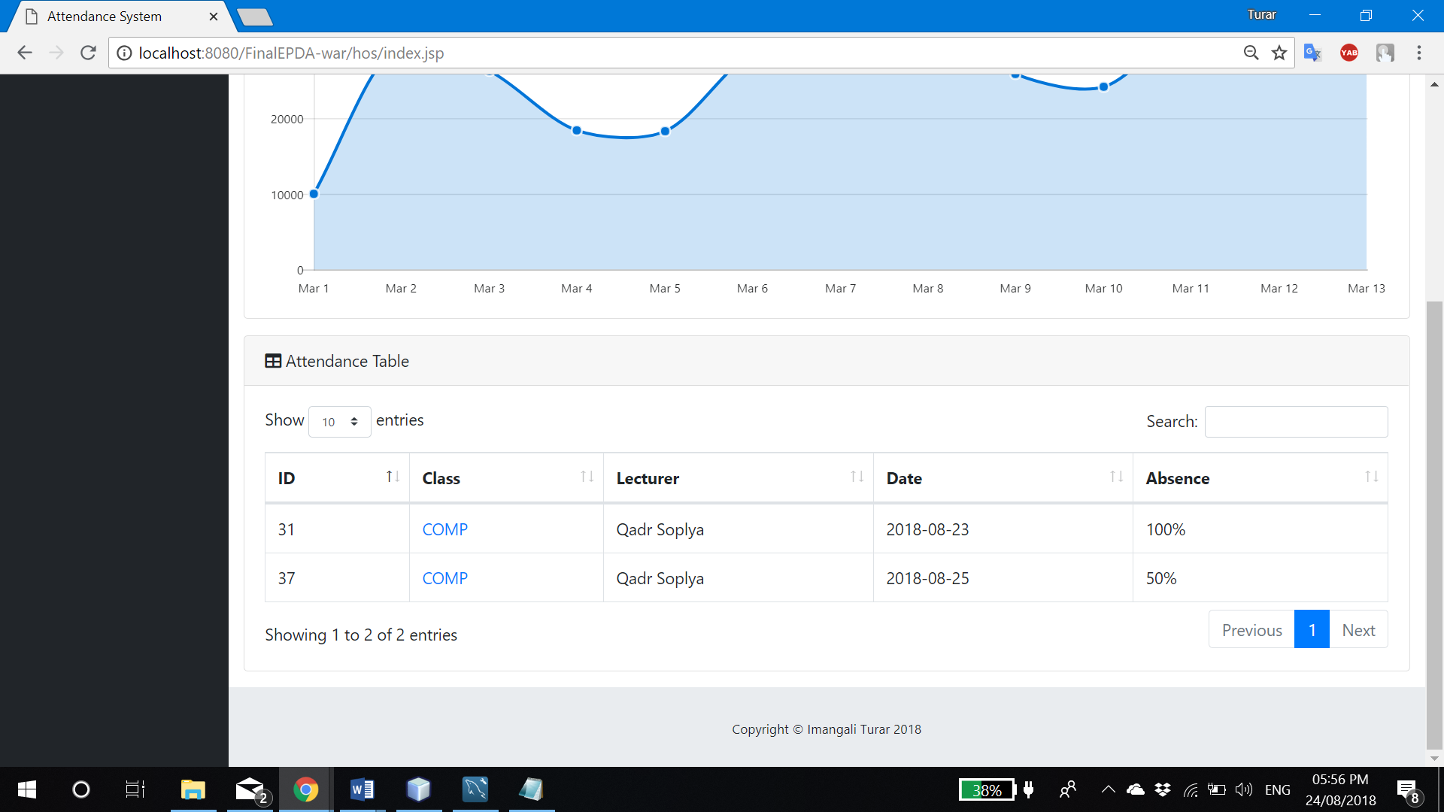

Figure 2.26: Attendance

In the bottom of the main page, HOS can see the attendance of classes, which belong to its department only (similar to admin’s feature, but admin could see all classes). Calculating of attendance is same as previous.

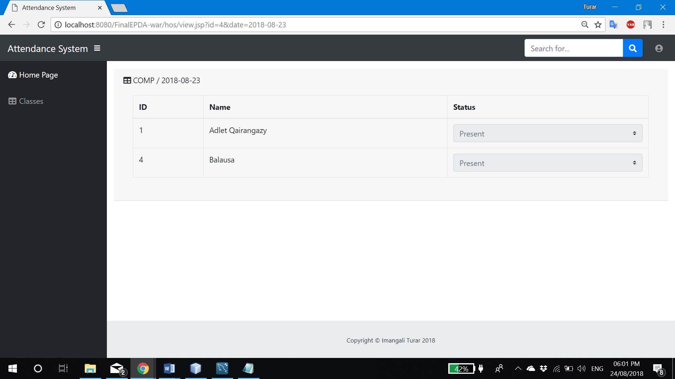

Figure 2.27: Details attendance

By clicking on class name at Figure 2.26, HOS can redirect to page which displays status of every student in that class.

## 2.4. Lecturer

### 2.4.1. Login

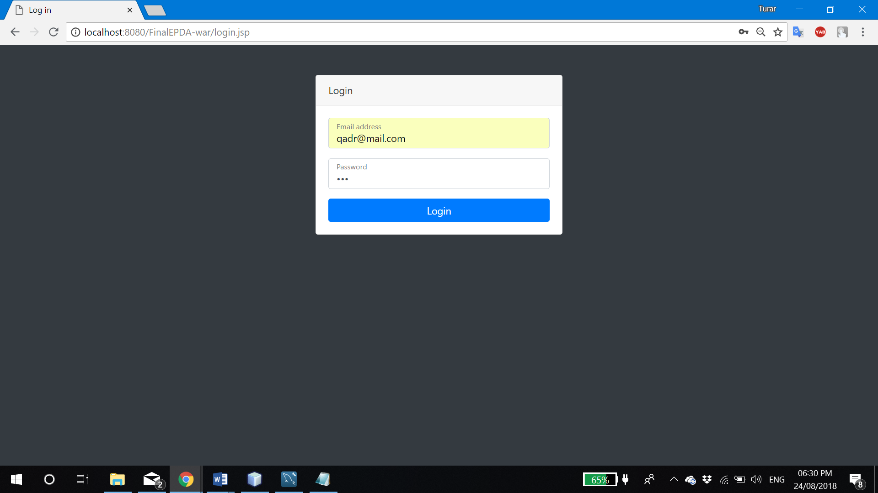

Figure 2.30: Lecturer login

Lecturer can be logged in by using its email as a username and IC number as password. Once user clicked “Login” button, entered information will be passed to the Login servlet to process it (Figure 2.2. Line 68-71). It will check if entered username and password satisfies lecturer’s login account, and if it does, servlet will set session ‘lecturer’ attribute to ‘user’ variable to be recognized in other pages as well as his own ID. If log in was successful, servlet will resend lecturer to its own main page at ‘lecturer/index.jsp’.

### 2.4.2. Edit profile

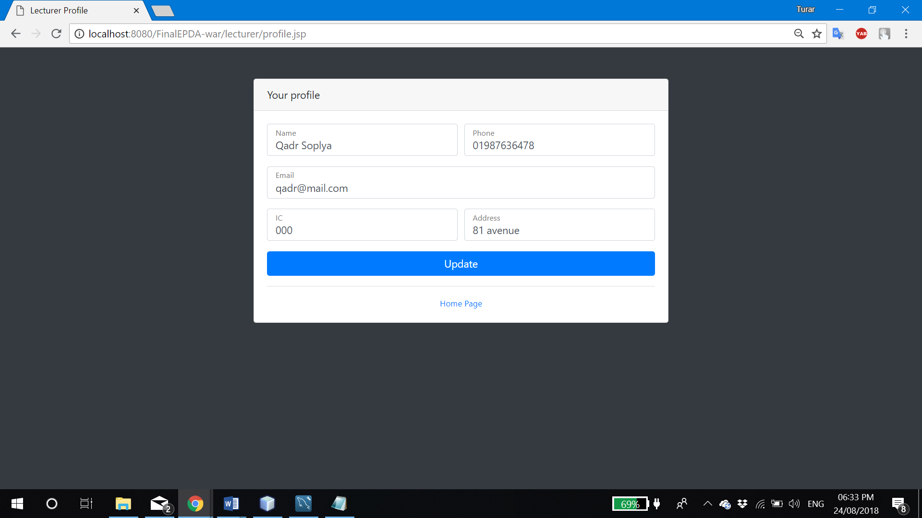

Figure 2.31: Edit lecturer profile

At ‘lecturer/profile.jsp’ user can change own profile information. To make update, user should click “Update” button, and all details will be sent to the “Update” servlet as seen in Figure 2.11 at line 48-60.

### 2.4.3. Take attendance

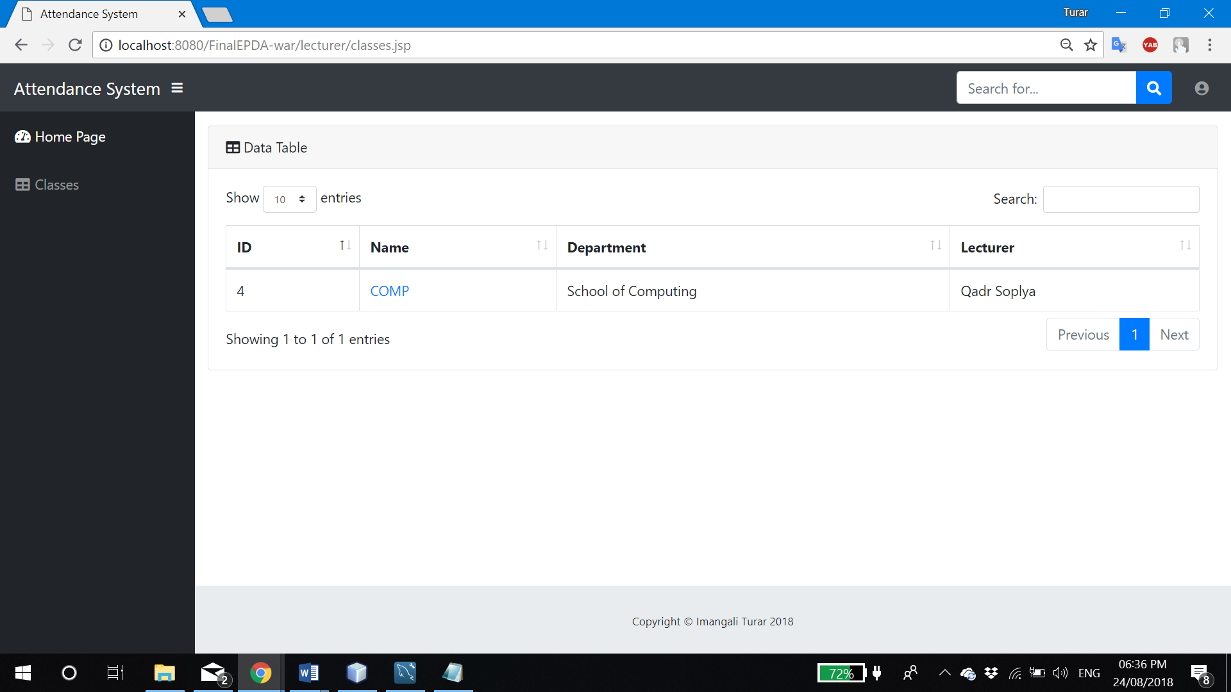

Figure 2.32: Classes

At ‘lecturer/classes.jsp’ lecturer can see all his classes, and by clicking name, it well sends him to the page to take attendance as in Figure 2.33.

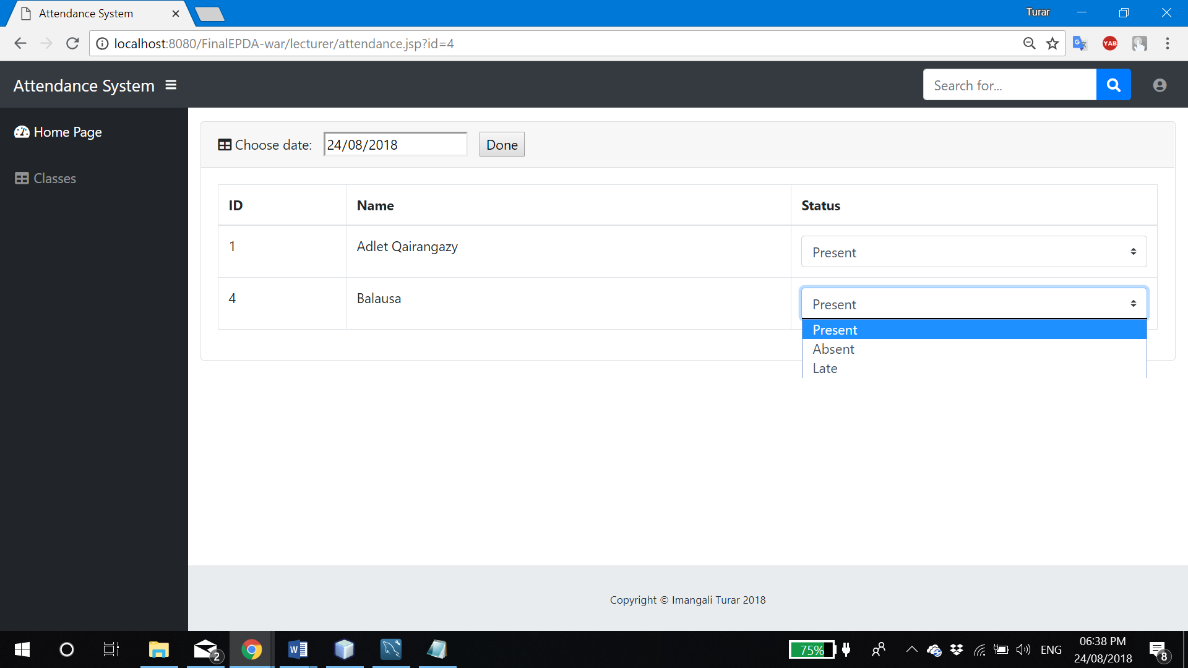

Figure 2.33: Taking attendance

Once lecturer entered date and selected absent/present/late to the form, by clicking ‘Done’ button it will send all data to ‘TakeAtt’ servlet for processing.

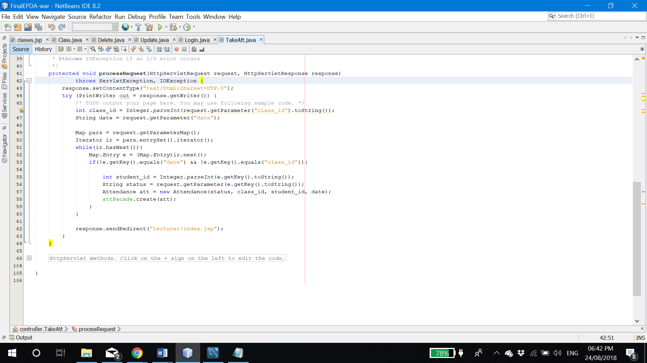

Figure 2.34: TakeAtt servlet

Servlet will take two values first, such as class ID and date. After that it will go through the map of attendance statuses and add new row to ‘Attendance’ database table via EJB.

### 2.4.4. Modify/view attendance

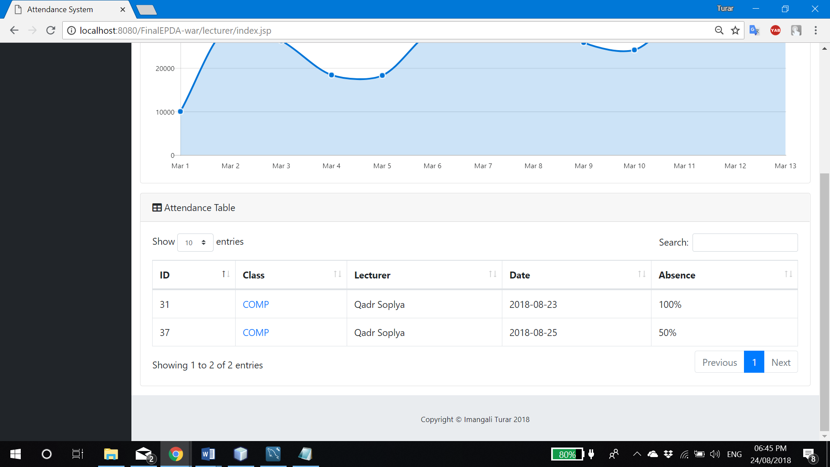

Figure 2.35: List of attendance

In the bottom of main page, lecturer can see the list of all attendances he ever made. On the top-right corner he is able to see search box by what he can find certain row by any column.

At the last column of every row, lecturer sees the percentage of presents in that particular cart. Sort by any column available as well. The name of class in every row is referring to the page for view/modification as shown in Figure 2.36.

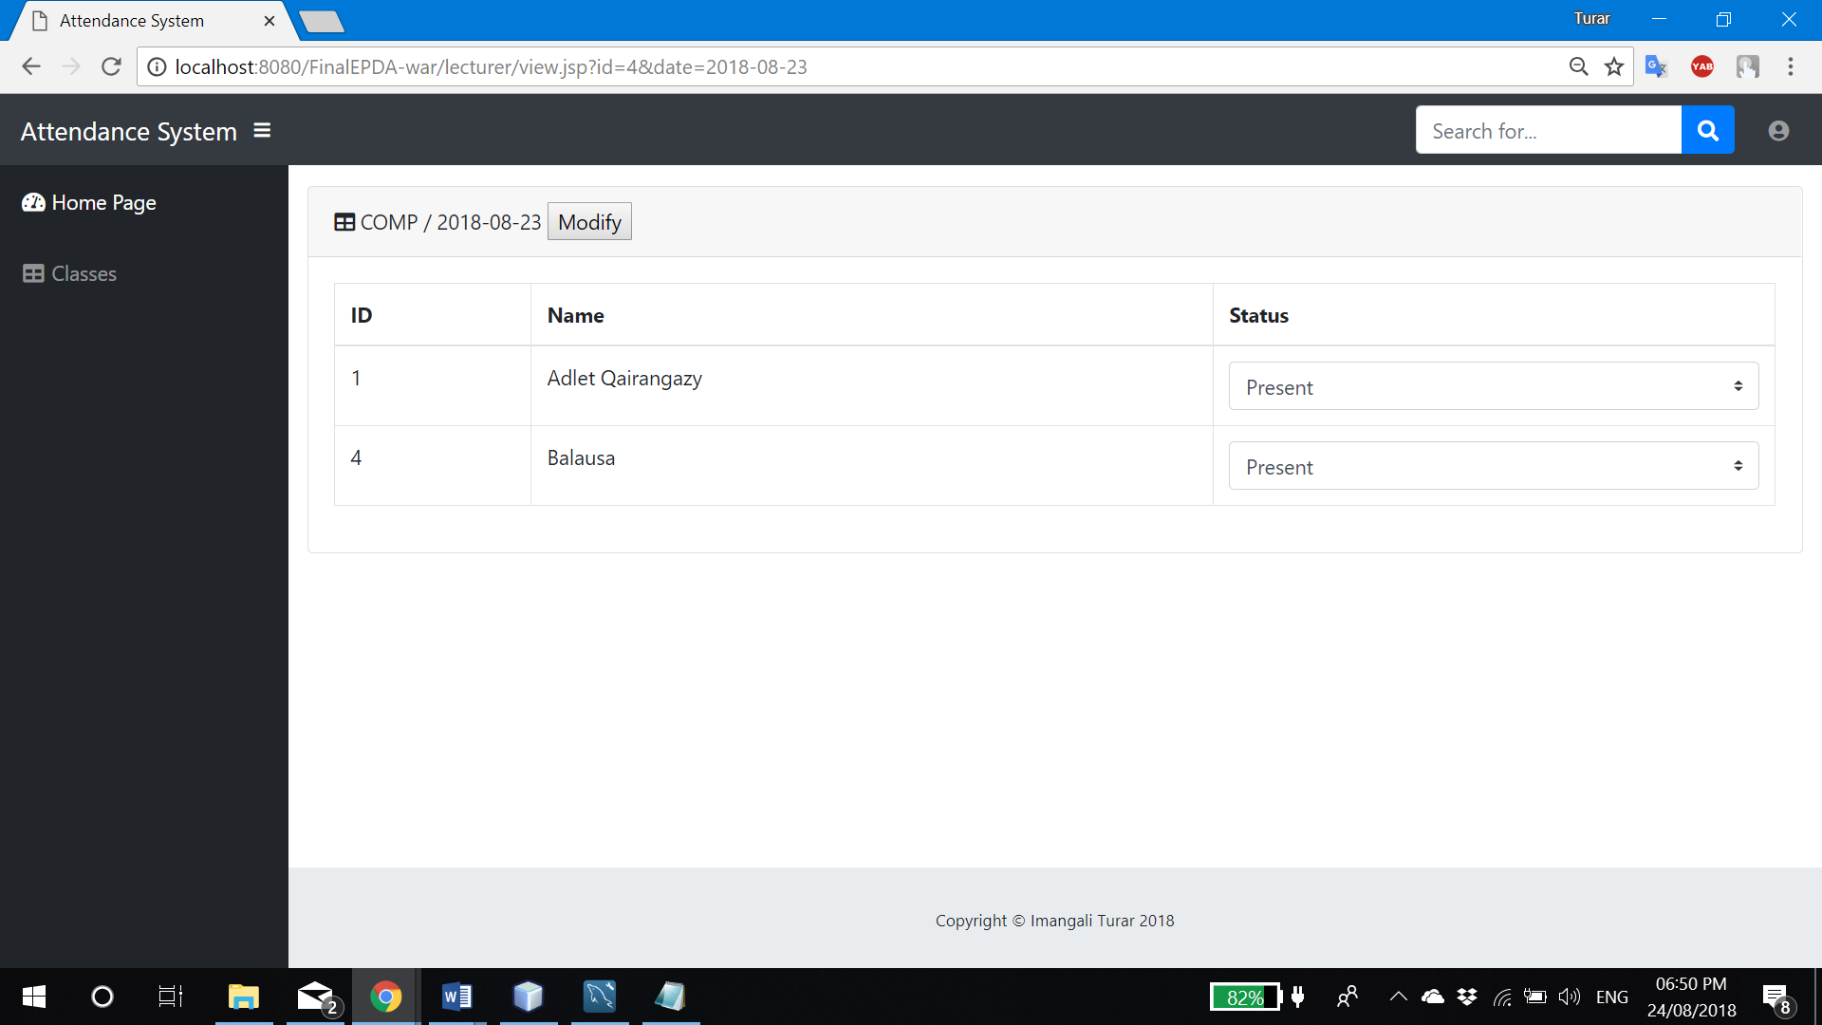

Figure 2.36: View/modify attendance

‘lecturer/view.jsp?id=**[class ID]**&date=**[class date]**’ shows the attendance of class by every student in class. The name of class and date of taken attendance is located on the top-left corner of the table. Lecturer can make changes by selecting necessary status of particular student and click ‘Modify’.

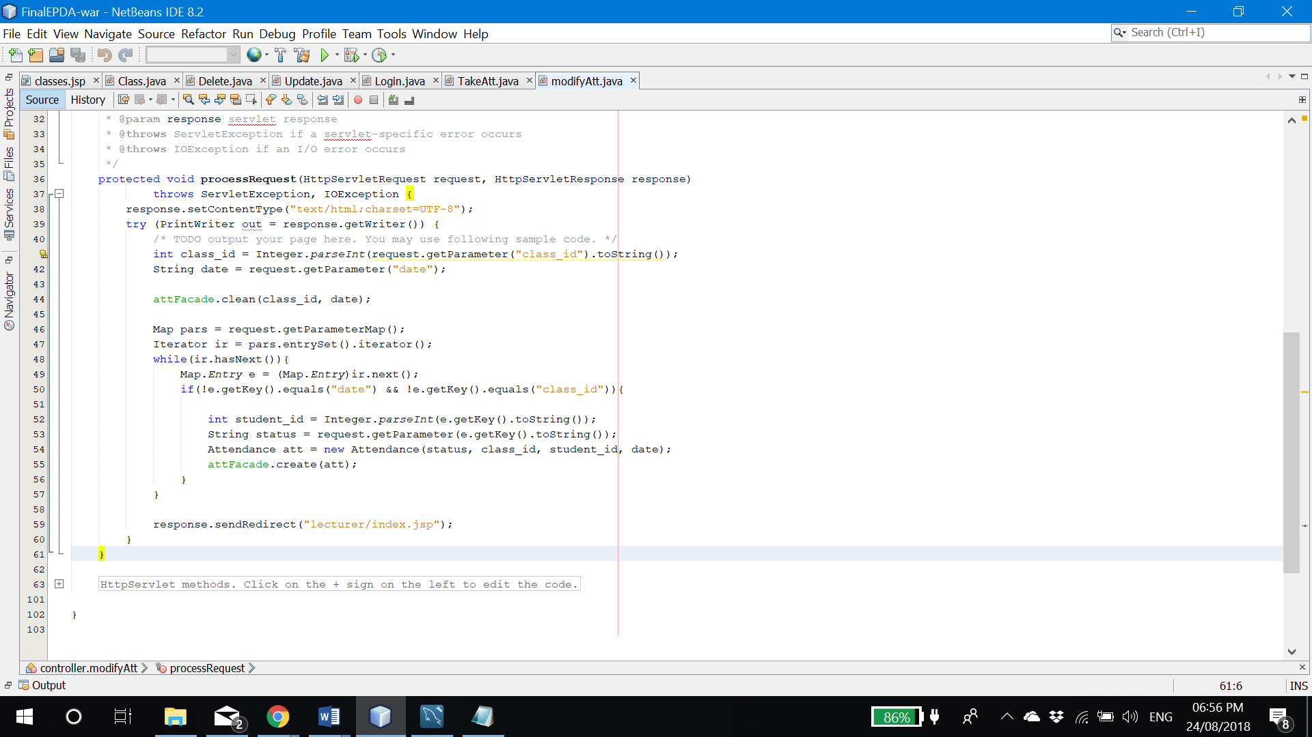

Figure 2.37: ModifyAtt servlet

After clicking ‘Modify’, all parameters will be passed to the ‘ModifyAtt’ servlet, which will remove all rows of attendances made by that day and class. And add new passed data to the database.

## 2.5. Student

### 2.5.1. Login

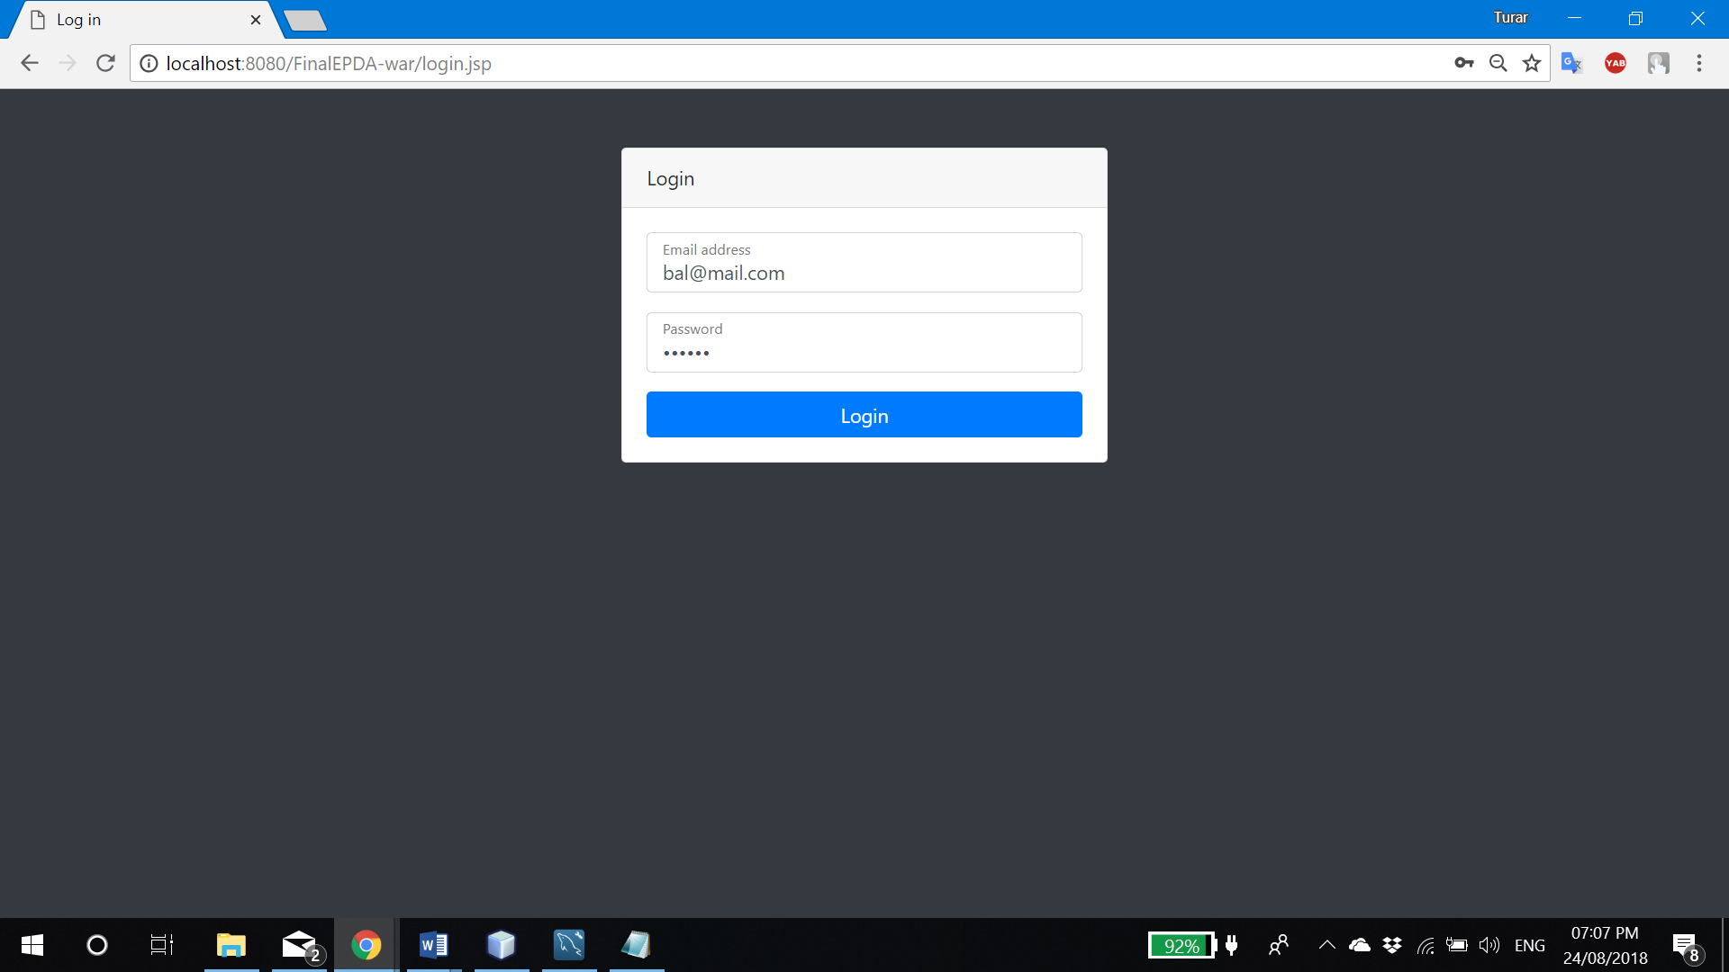

Figure 2.38: Student login

Student can be logged in by using its email as a username and IC number as password. Once user clicked “Login” button, entered information will be passed to the Login servlet to process it (Figure 2.2. Line 74-77). It will check if entered username and password satisfies student’s login account, and if it does, servlet will set session ‘student’ attribute to ‘user’ variable to be recognized in other pages as well as his own ID. If log in was successful, servlet will resend student to its own main page at ‘student/index.jsp’.

### 2.5.2. Edit profile

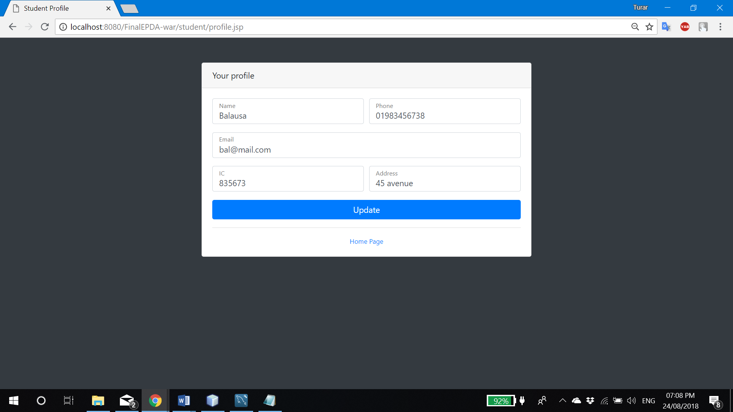

Figure 2.39: Edit student profile

At ‘student/profile.jsp’ user can change own profile information. To make update, user should click “Update” button, and all details will be sent to the “Update” servlet as seen in Figure 2.11 at line 62-73.

### 2.5.3. View attendance summary

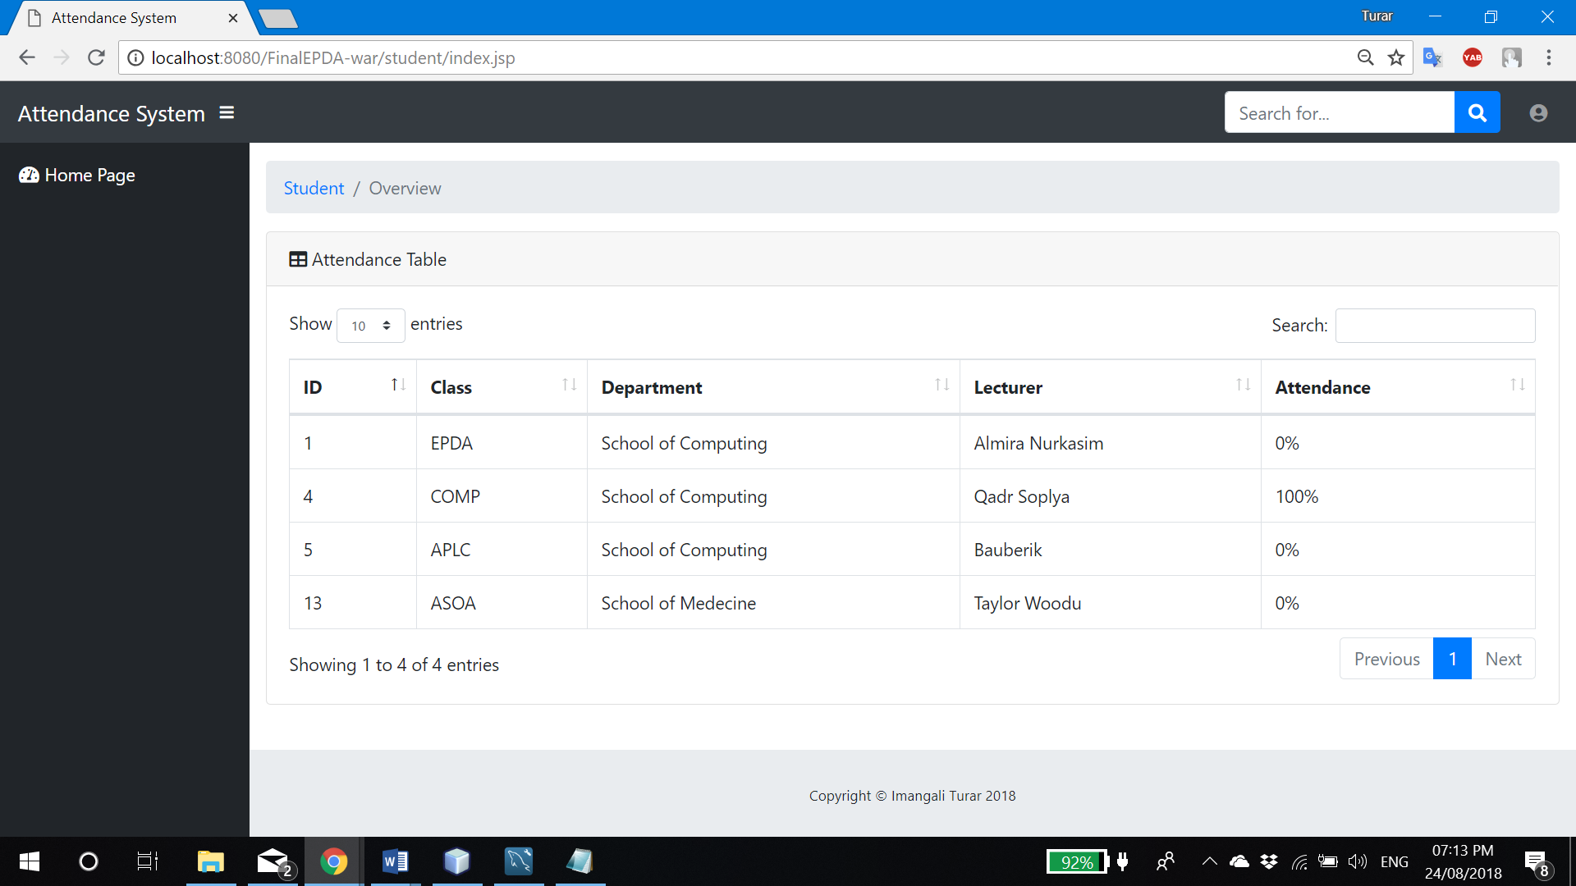

Figure 2.40: View attendance

At the home page, student is able to see the percentage of attendance of classes he is enrolled. Using that table in Figure 2.40. student can search any subject he wants by any column and make any kind of sort using columns. Pagination of can be customized by student itself, it is available on the top-left side of table.

Update will be processed by ‘Update’ servlet as in Figure 2.11. at lines 75-79. And removing process will happen in ‘Delete’ servlet as shown in Figure 2.12. at lines 66-78.

# 3. Business Tier

## 3.1. Introduction

### 3.1.1. Entity Beans

An entity bean, in the context of Java Platform 2, Enterprise Edition (J2EE), represents the business objects retained at the end of a session in a persistent storage mechanism. Business objects may include items like customer name, account number and/or account balance, etc. In J2EE, a relational database is a persistent storage mechanism. In a relational database, there is a table for each entity bean and every bean instance corresponds to a particular table row.

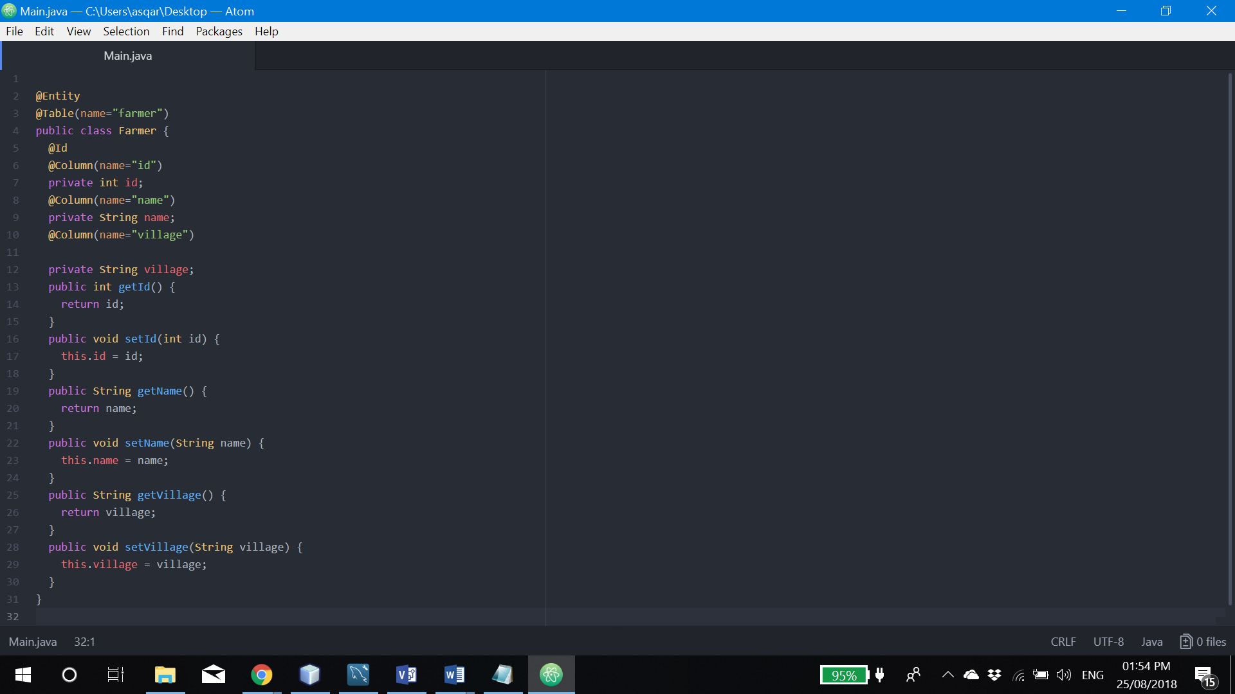

Figure 3.1: Entity bean example

The two different types of entity bean persistence are bean-managed and container-managed. An entity bean is persistent because it is stored in a relational database, where data exists after a session ends.

Multiple clients may share entity beans. Entity transaction management is important because at any given time, different clients may need to access and change the same data. Each bean’s transaction management is provided by the Enterprise JavaBeans (EJB) container, which guarantees data integrity.

Each entity bean is identified by a unique object identifier, which is used by the client to locate a specific entity bean. Entity beans may be used when a bean is a business object and not a method. For example, a bank account is a business object, whereas bank account verification is a business method. An entity beam may also be used if a bean’s state should remain persistent.

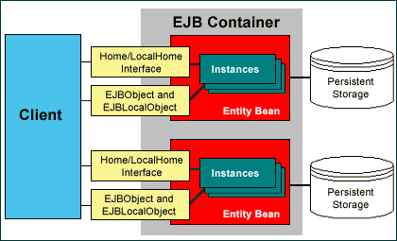

Figure 3.2: Entity beans diagram

### 3.1.2. Session Beans

A stateless session bean does not maintain state with the client. When a client invokes the methods of a stateless bean, the bean’s instance variables may contain a state specific to that client, but only for the duration of the invocation. When the method is finished, the client-specific state should not be retained.

Clients may, however, change the state of instance variables in pooled stateless beans, and this state is held over to the next invocation of the pooled stateless bean. Except during method invocation, all instances of a stateless bean are equivalent, allowing the EJB container to assign an instance to any client. That is, the state of a stateless session bean should apply across all clients.

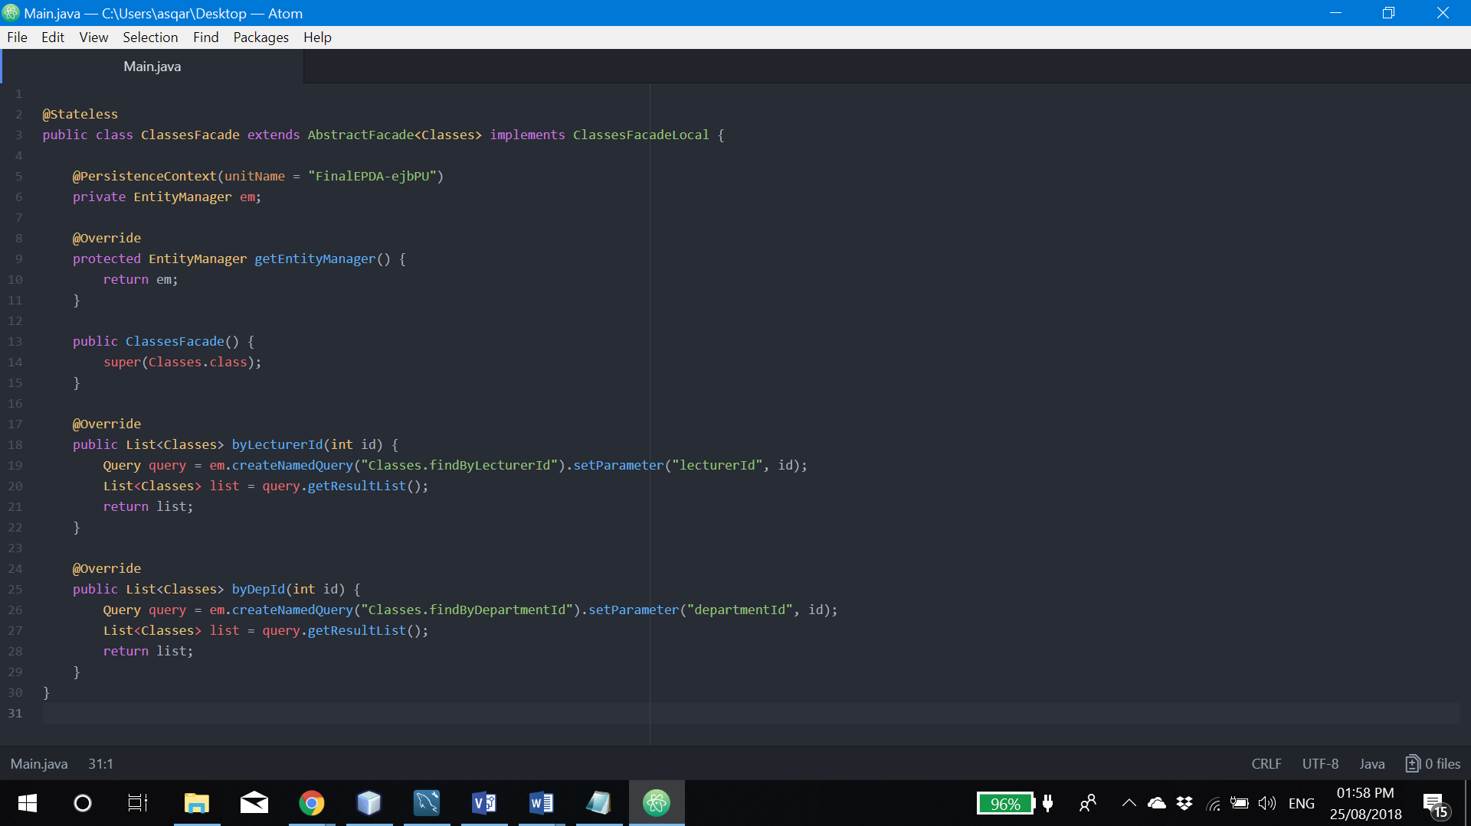

Figure 3.3: Session Beans example

### 3.1.3. Diagram



Figure 3.4: Entity and session beans

Figure above represents the relationship between entity and session beans in my assignment.

## 3.2. EJB

### 3.2.1. Lecturers

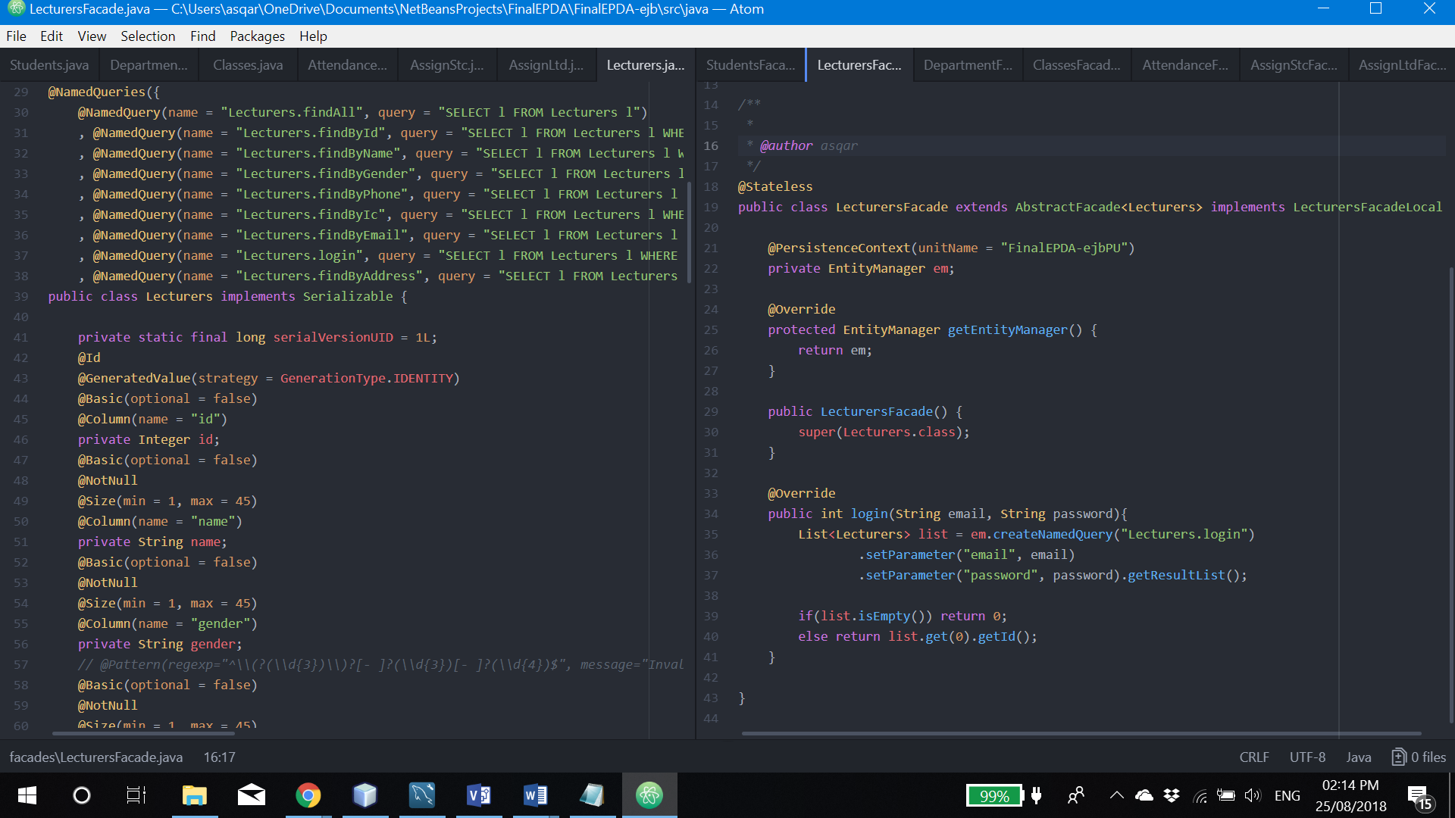

Figure 3.5: Lecturer session and entity bens

All sessions beans façades in my system are extended by main ‘AbstractFacade’ abstract class. ‘LecturerFacade’ got additional method which called login(String mail, String password). It is responsible to match entered to data with every row in database. And if one of row is matched, method will return its ID, otherwise 0.

### 3.2.2. Students

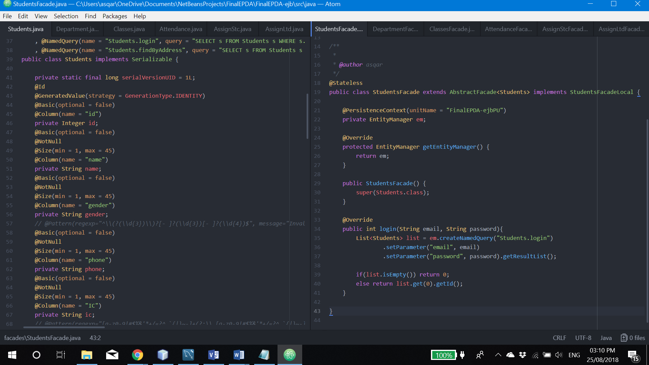

Figure 3.6: Students

Behavior of login method here is same as I described above.

### 3.2.3. AssignLtd

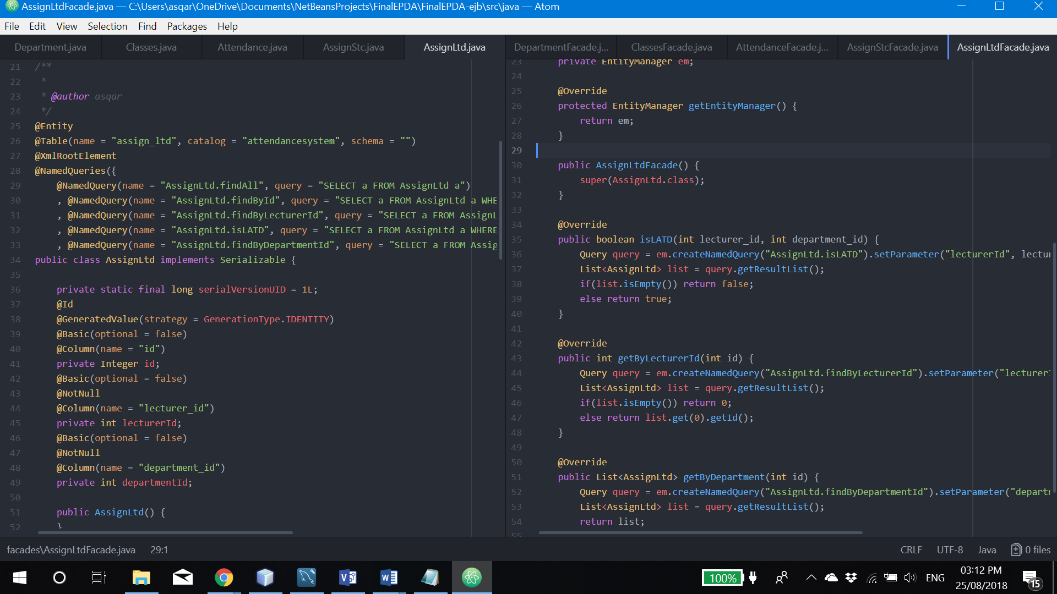Figure 3.7: AssignLtd

This beans are responsible on managing data of lecturers assigned to department. 3 additional methods are implemented to the façade.

* isLATD(int lecturer_id, int department_id) will return true or false, based on the result it get by searching for same data as passed parameters.
* getByLecturerId(int id) returns the ID of records, belonged to the certain lecturer
* getByDepartmentId(int id) returns the list of records of assigned to particular department

### 3.2.4. AssignStc

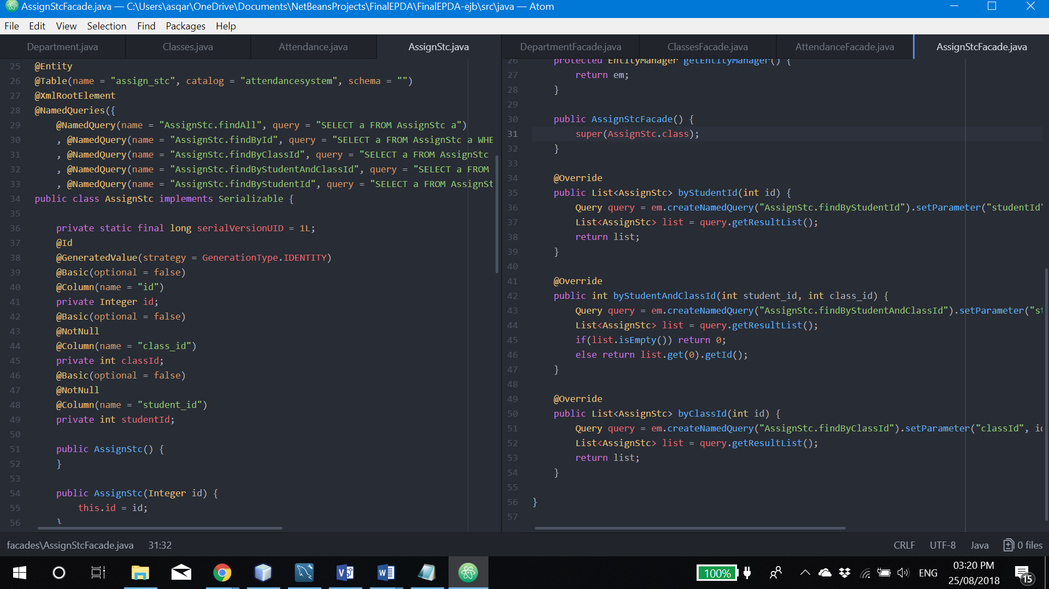

Figure 3.8: AssignStc

* byStudentId(int id) return the list of records of particular student
* byStudentAndClassId(int student_id, int class_id) returns the ID number of record which matches the past parameters.
* byClassId(int id) returns the list of assigned students, based on particular class

### 3.2.5. Department

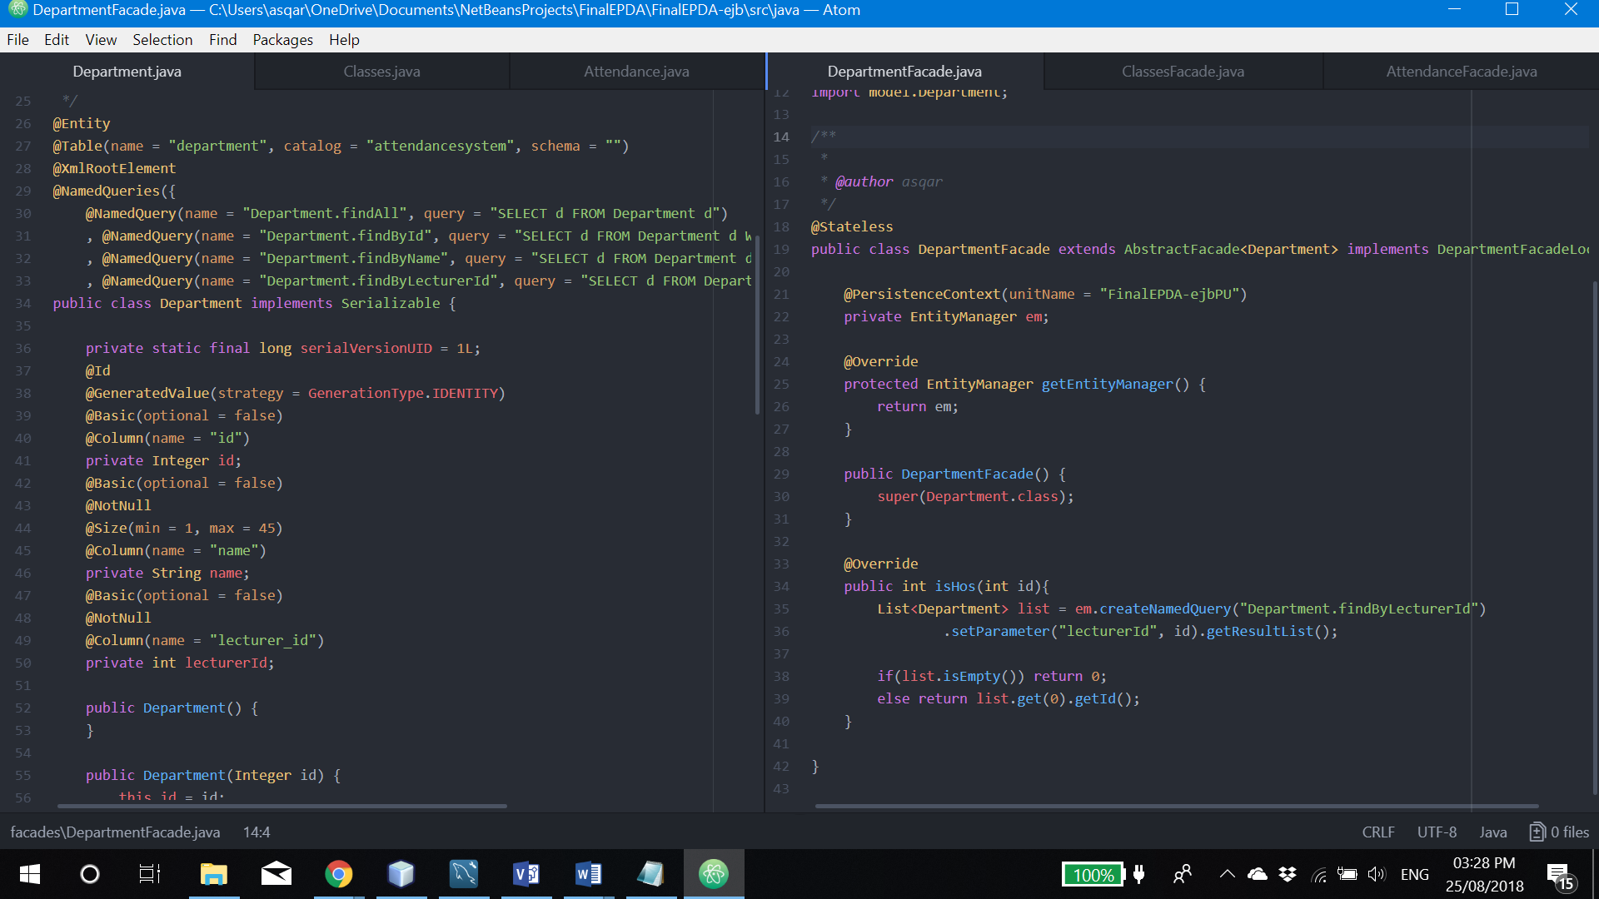

Picture 3.9: Department

The only single one additional method idHos(int id) implemented in order to check, if lecturer is a head of any department or not. If it is, method will return ID of department, otherwise 0.

### 3.2.6. Classes

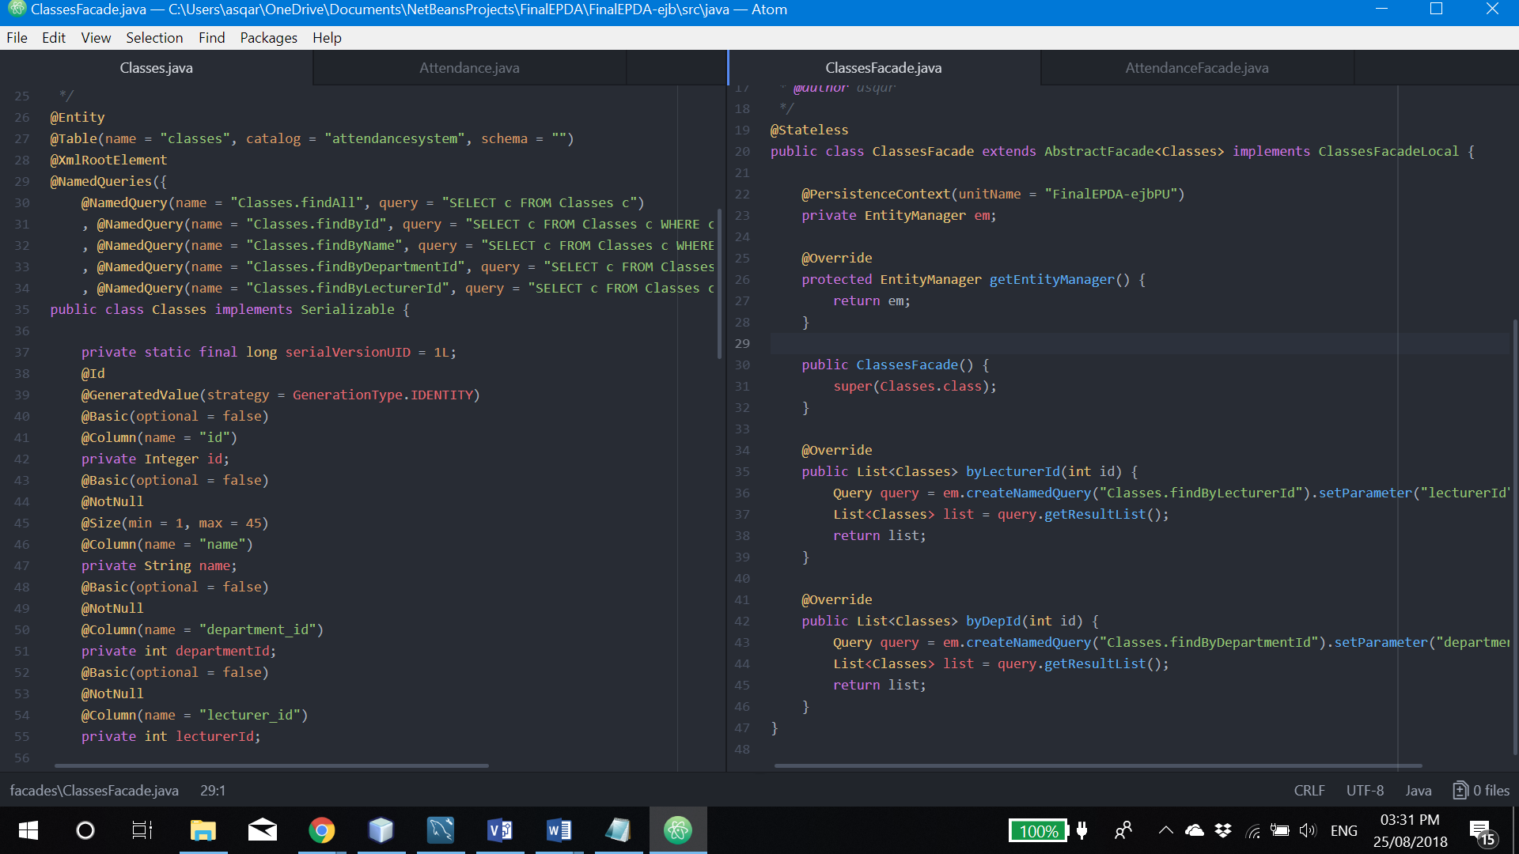

Figure 3.10: Classes

byLecturerId(int id) and byDepId(int id) are return the list, based on parameters method got.

### 3.2.7. Attendance

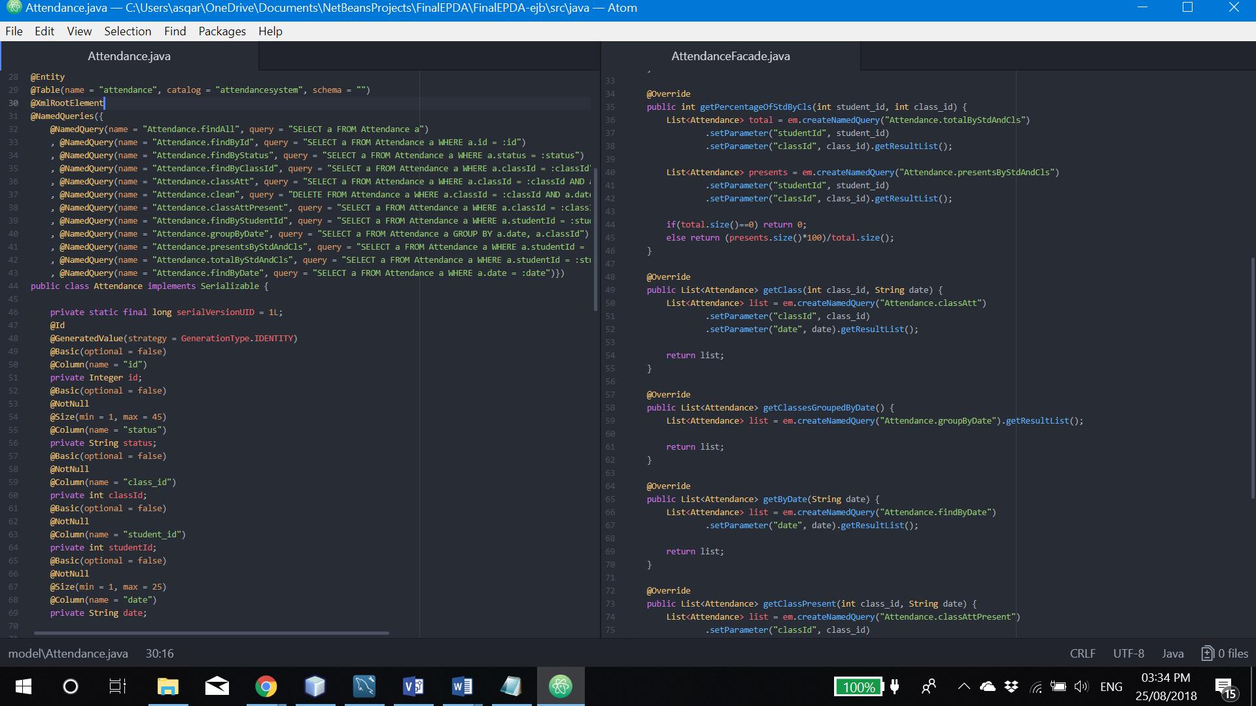

Figure 3.11: Attendance

* getClassesGroupedByDate() returns the list of ‘SELECT a FROM Attendance a GROUP BY a.date, a.classId’ query. It will allow as to get all records, ordered by particular class.
* getPercentageOfStdByCls(int class_id, int student_id) return the percentage of attendance in certain class by formula: (presents.size()*100)/total.size().
* getClass(int class_id, String date) returns ID of row, matched passed parameters.
* getByDate(String date) return the list of all records of that date.
* getClassPresents(int class_id, String date) returns list of attendance with present status records
* getByClass(int class_id) returns a list of attendance by single class
* clean(int class_id, String date) will delete of recorded attendance rows in order to allow lecturer to update and rewrite taken attendance

# 4. Database Tier

## 4.1. Diagram

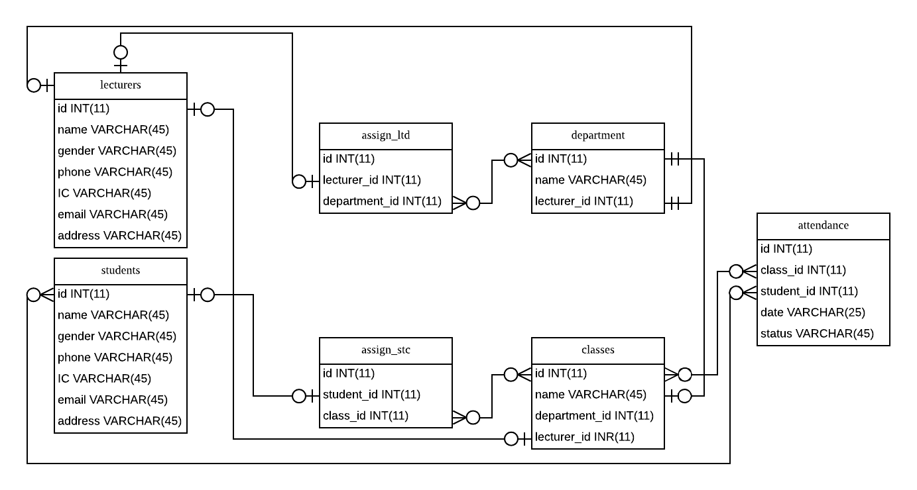

Figure 4.1: Database diagram

## 4.2. Tables

### 4.2.1. Lecturers and Students

This two tables will keep data of all our users’ details such as name, gender, phone number, IC number, email and address. Email and IC is used to log in into the system.

### 4.2.2. Assign_LTD

Tables is responsible on keeping track of all lecturers to which department he or she is assigned. Table consists lecturer ID and department ID columns.

### 4.2.3. Assign_STC

This table is similar to 4.2.2. but instead of lecturers and departments, this table will record students to which class particular student is assigned. Student ID and class ID columns is involved.

### 4.2.4. Class

All available classes are stored in this table. Columns such as name, department ID and lecturer ID is identified.

### 4.2.5. Department

Departments information such as leader of department and department name stored here.

### 4.2.6. Attendance

To keep track the attendance of every student taken by lecturer is recorded in this table. It has columns such as class ID, student ID, date and finally status.

# 5. Summary of Entire Architecture

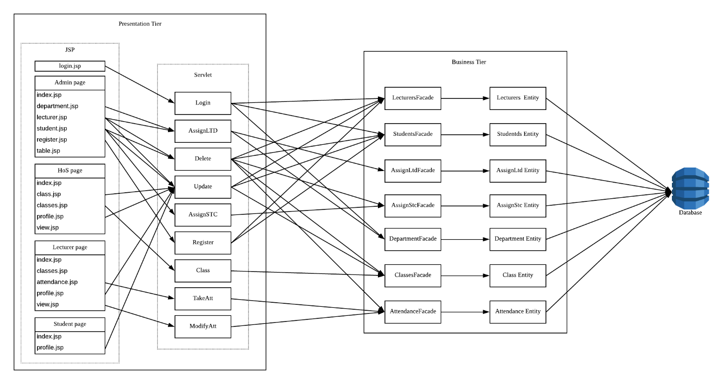

Figure 5.1: 3-tiers architectural diagram

During this assignment I assess the distributed technology of Java Enterprise Edition in the context of distributed enterprise applications. The diagram above (Figure 5.1) describes the architecture of my distributed application and the relationships between components and each tier. I created and tested all the components and provided clients access to these components.

Organizing, installing and testing an ‘Attendance System’ which is distributed java technology application has been challenging, but it gave me the opportunity to understand about this powerful technique in practice by actually implementing it. Critically evaluate a variety of distributed enterprise object-based systems by examining characteristics such as architectures, methods of communication, naming, synchronization, and replication has been achieved as well.

# 6. Additional Features

## 6.1. JavaScript

JavaScript is a cross-platform, object-oriented scripting language used to make webpages interactive (e.x. having complex animations, clickable buttons, popup menus, etc.). There are also more advanced server side versions of javascript such as Node.Js which allow you to add more functionality to a website than simply downloading files (such as realtime collaboration between multiple computers). Inside a host environment (for example, a web browser), JavaScript can be connected to the objects of its environment to provide programmatic control over them.

Below is a minimal example of a standards-conforming Web page containing JavaScript (using HTML 5 syntax) and the DOM:

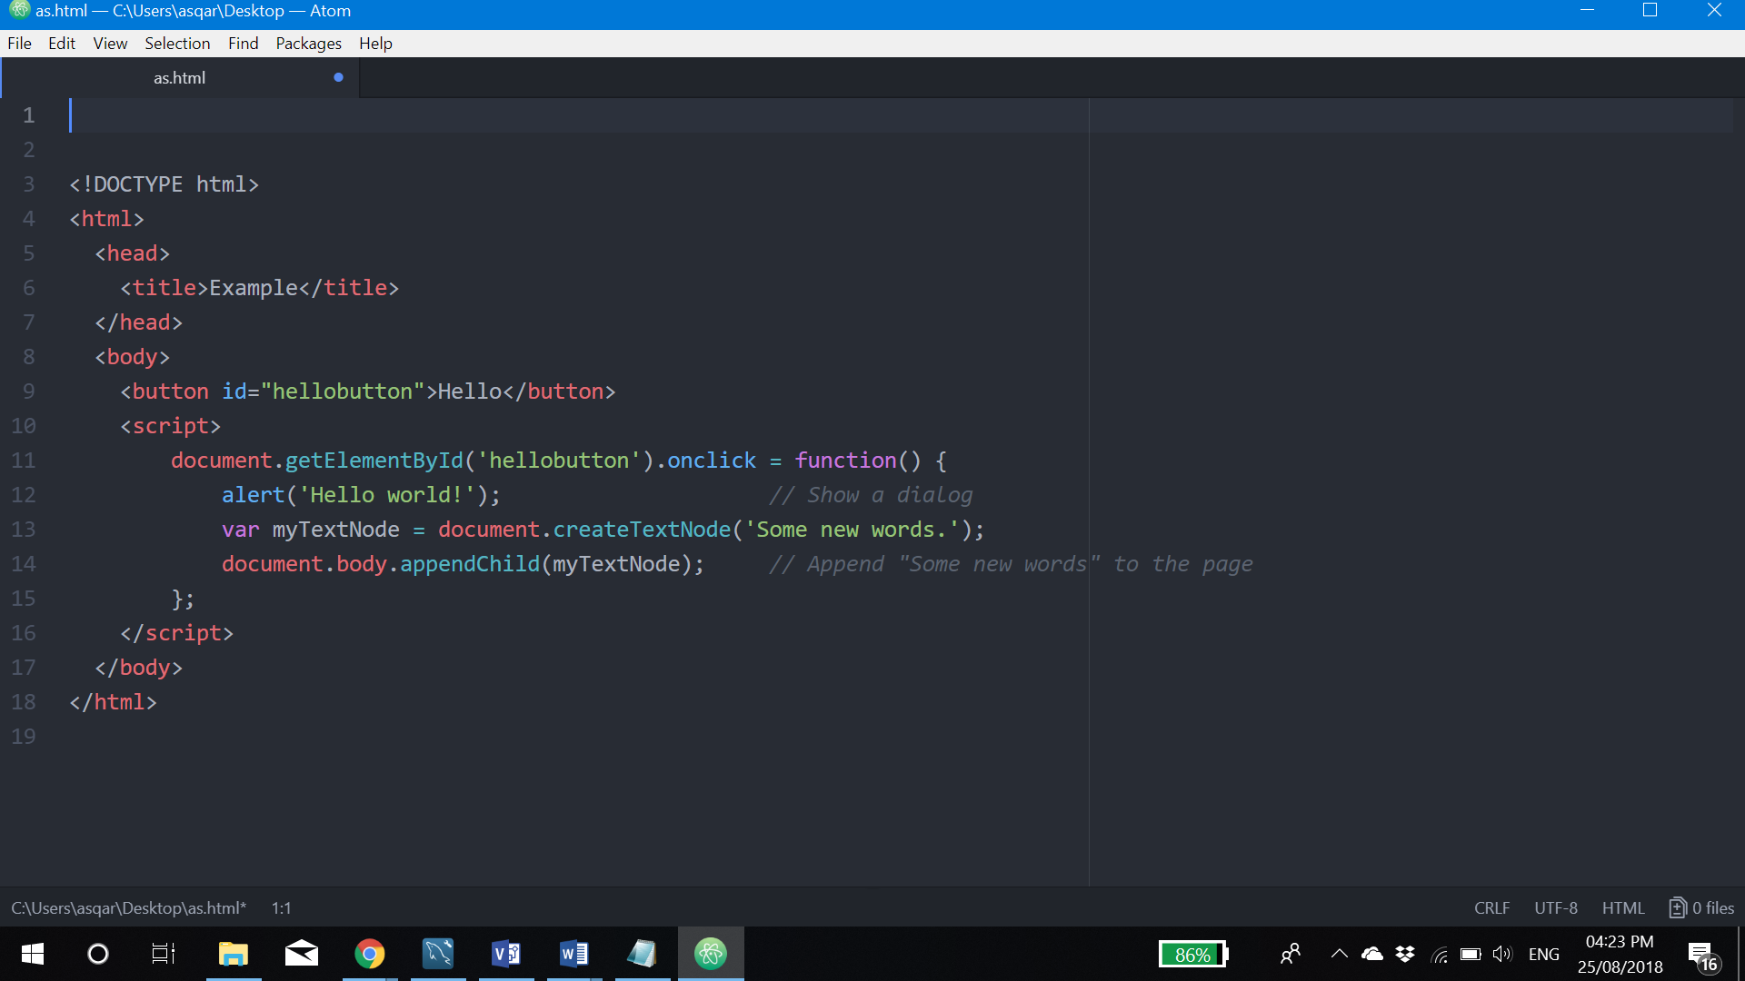

Figure 6.1: JavaScript example

Because JavaScript code can run locally in a user's browser (rather than on a remote server), the browser can respond to user actions quickly, making an application more responsive. Furthermore, JavaScript code can detect user actions that HTML alone cannot, such as individual keystrokes. Applications such as Gmail take advantage of this: much of the user-interface logic is written in JavaScript, and JavaScript dispatches requests for information (such as the content of an e-mail message) to the server. The wider trend of Ajax programming similarly exploits this strength.

## 6.2. CSS

Cascading Style Sheets, fondly referred to as CSS, is a simple design language intended to simplify the process of making web pages presentable.

CSS handles the look and feel part of a web page. Using CSS, you can control the color of the text, the style of fonts, the spacing between paragraphs, how columns are sized and laid out, what background images or colors are used, layout designs,variations in display for different devices and screen sizes as well as a variety of other effects.

The following very simple example of a portion of an HTML document illustrates how to create a link within a paragraph. When rendered on the screen (or by a speech synthesizer), the link text will be “final report”; when somebody activates the link, the browser will retrieve the resource identified by “http://www.example.com/report”:

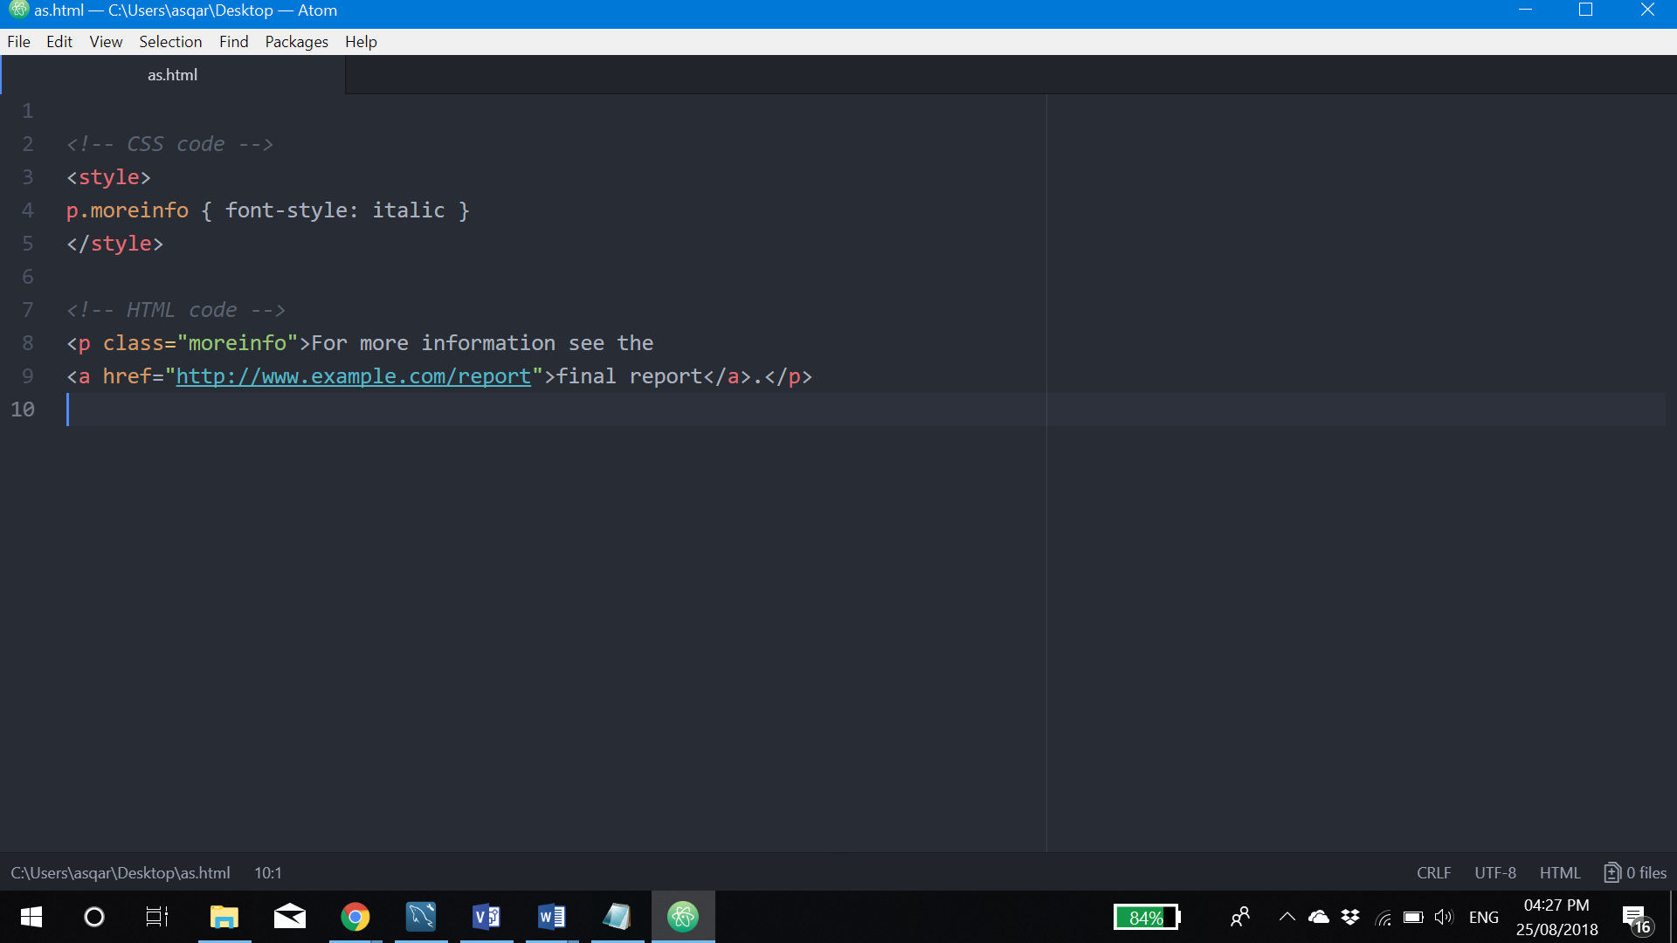

Figure 6.2: CSS example

The class attribute on the paragraph's start tag (“<p>”) can be used, among other thing, to add style. For instance, to italicize the text of all paragraphs with a class of “moreinfo,” one could write as in Figure 6.2. at line 4. By placing that rule in a separate file, the style may be shared by any number of HTML documents.

## 6.3. Bootstrap Framework

Bootstrap is a free and open-source front-end framework for designing websites and web applications. It contains HTML- and CSS-based design templates for typography, forms, buttons, navigation and other interface components, as well as optional JavaScript extensions. Unlike many web frameworks, it concerns itself with front-end development only [Wikipedia]. Bootstrap is the second most-starred project on GitHub, with more than 126,000 stars [GitHub.com].

As you can see from screenshots of web pages in chapter 2, where I described presentation tier, I used bootstrap framework in order to achieve user friendly interface.

For example, using the most basic table markup, here’s how **.table** based tables look in Bootstrap. All table styles are inherited in Bootstrap 4, meaning any nested tables will be styled in the same manner as the parent.

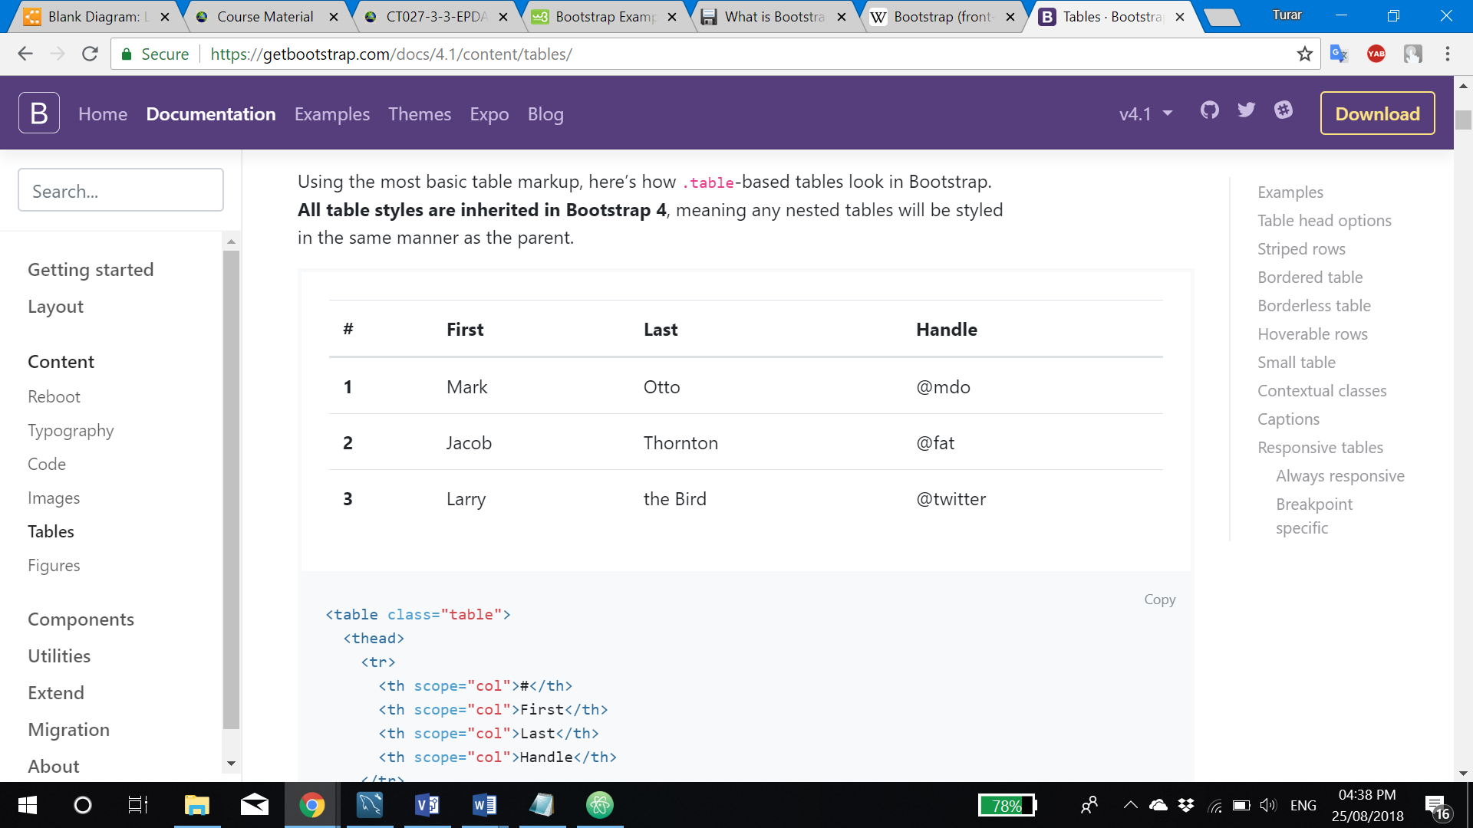

Figure 6.3: Table example

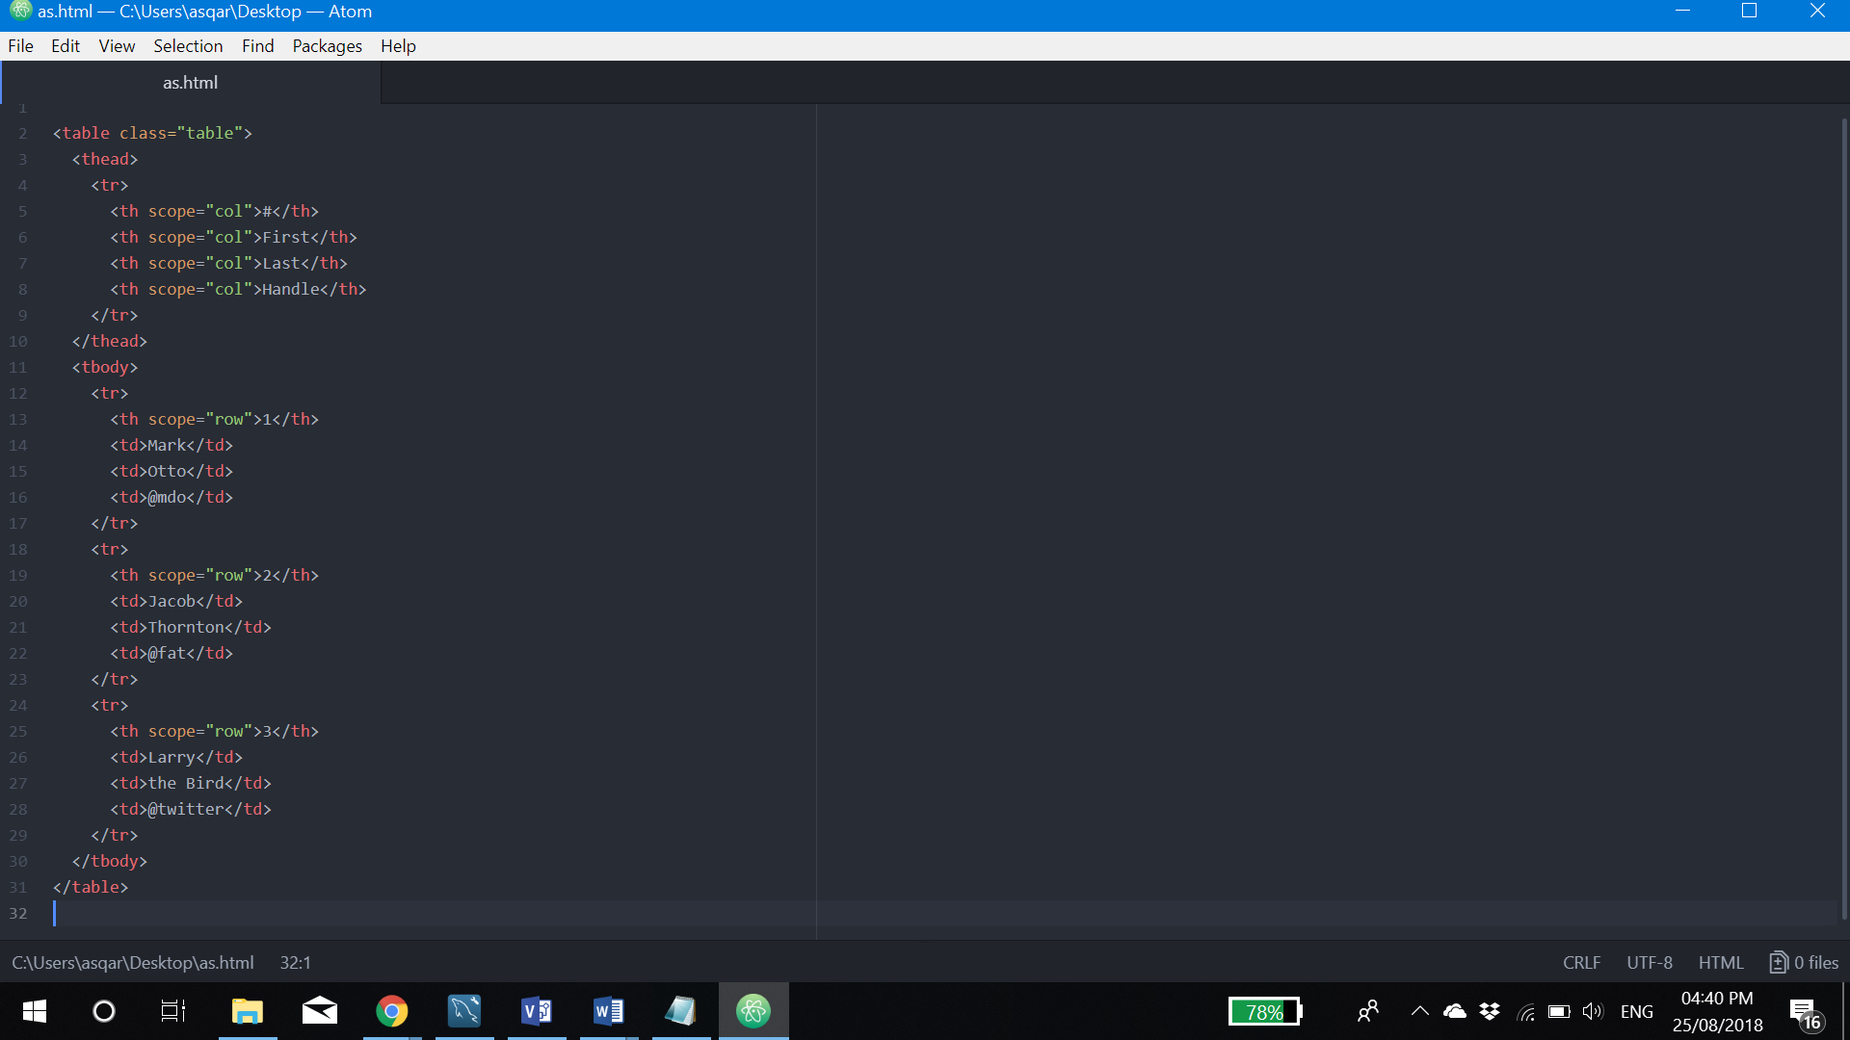

Figure 6.4: HTML code of table in Bootstrap

You can also invert the colors—with light text on dark backgrounds—with **.table-dark**.

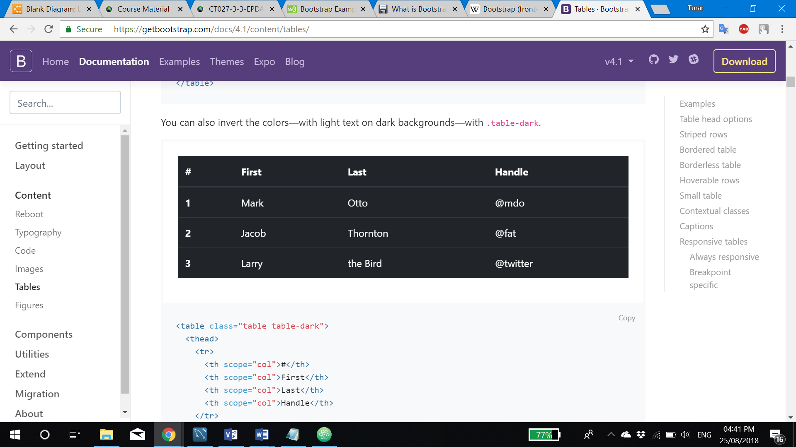

Figure 6.5: Dark table example

# 7. References

1. Ghosh, Sukumar (2007), Distributed Systems – An Algorithmic Approach, Chapman & Hall/CRC, ISBN 978-1-58488-564-1.
2. Coulouris, George; Jean Dollimore; Tim Kindberg; Gordon Blair (2011). Distributed Systems: Concepts and Design (5th Edition). Boston: Addison-Wesley.
3. Tel, G. (2000). Introduction to Distributed Algorithms. Cambridge University Press. pp. 35–36.
4. Ohlídal, M.; Jaroš, J.; Schwarz, J.; et al. (2006). "Evolutionary Design of OAB and AAB Communication Schedules for Interconnection Networks". In Rothlauf, F.; Branke, J.; Cagnoni, S.; et al. Applications of Evolutionary Computing. Springer Science & Business Media.
5. Ms.Kamble, "Real Time And Distributed Computing Systems" (2005). ISSN 2278-0661. Retrieved 2017-01-09.
6. Lind P, Alm M (2006), "A database-centric virtual chemistry system", J Chem Inf Model, 46 (3): 1034–9, doi:10.1021/ci050360b, PMID 16711722.
7. Cormen, Thomas H.; Leiserson, Charles E.; Rivest, Ronald L. (1990), Introduction to Algorithms (1st ed.), MIT Press, ISBN 0-262-03141-8.
8. Cole, Richard; Vishkin, Uzi (1986), "Deterministic coin tossing with applications to optimal parallel list ranking", Information and Control, 70 (1): 32–53.
9. Oracle.com. (2018). Oracle Technology Network for Java Developers | Oracle Technology Network | Oracle. [online] Available at: http://www.oracle.com/technetwork/java/index.html [Accessed 25 Aug. 2018].
10. Kumar, B., Narayan, P. and Ng, T. (2010). Implementing SOA using Java EE. Upper Saddle River, N.J.: Addison-Wesley.
11. Goncalves, A. (2009). Beginning JavaTM EE 6 Platform with GlassFishTM 3. Berkeley, CA: Apress.

# 8. Marking Scheme

/* MAKING SCHEME */